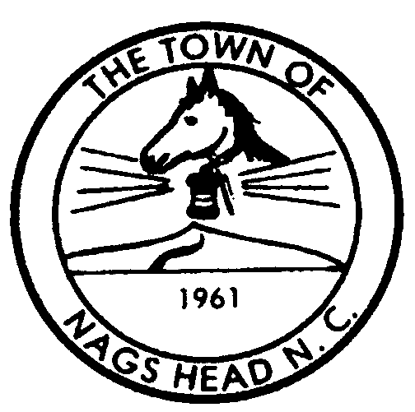
Town of Nags Head

Planning and Development Post Office Box 99 Telephone 252-441-7016
Department Nags Head, North Carolina 27959 FAX 252-441-4290
www.townofnagshead.net

MEMORANDUM

TO: Board of Commissioners
FROM: Planning Board and Development Staff
DATE: February 18, 2004
SUBJECT: Request for public hearing to consider staff’s proposed zoning text amendment to establish specific minimum setbacks for religious complexes in the SPD-20 zoning district.
Recently staff was reviewing a building permit application from a religious complex located in the SPD-20 zoning district. In the course of the zoning review, staff realized that section 22-351 C.1. Of the zoning ordinance appears to lack specific minimum setback requirements for principal buildings of religious complexes in the SPD-20 zoning district. Religious complexes are currently permitted as conditional uses in the R-2 Medium Density Residential, R-3 High Density Residential, C-2 General Commercial, and SPD-20 zoning districts. In all of these districts except SPD-20, a specific condition related to setbacks for structures reads:

“No structure shall be located closer than twenty-five (25) feet to a common property line, nor closer than thirty feet (30) feet to an abutting street or highway right-of-way.”

Although in March of 1986 the Zoning Ordinance was amended to add religious complexes to the SPD-20 District with the setback language above, today’s zoning ordinance contains only the following requirement pertaining to setbacks for religious complexes in SPD-20:

“With the exception of signs permitted in accordance with Section 22.545 of the Zoning Ordinance, all accessory structures and uses shall meet the required front, rear, and side, setbacks.”

Staff and the Town clerk have investigated, but not determined how, when or why this language was modified to appear as it does today. The purpose of the attached amendment however, is to replace the current language with the identical structure setback regulations applicable to religious complexes in each of the other zoning districts in the Town.

Planning Board Recommendation:

At their regular meeting of February 17, 2004, the six (6) members of the Planning Board discussed the attached zoning text amendment. They agreed with staff’s opinion that the amendment should be adopted to make religious complex regulations more consistent throughout the Town. The Planning Board members voted unanimously to recommend adoption of the attached zoning text amendment as presented.

Staff recommendation:

Staff recommends that the attached zoning text amendment be approved for adoption as presented for the following reasons:

- It is staff’s opinion that the absence of a minimum setback requirement for principal buildings of religious complexes in the SPD-20 district needs to be addressed before the current religious complex regulations are challenged or applied in a manner not intended or desired by the Town.
- The proposed amendment is the same language that was originally approved and adopted in 1986 for religious complexes in the SPD-20 zoning district.
- If adopted as presented, setbacks for religious complexes in the SPD-20 district would be consistent with the regulation of religious complex buildings in the other zoning districts in the Town where religious complexes are permitted.
- The amendment if adopted would improve the overall clarity and consistency of the zoning ordinance as it pertains to the regulation of religious complexes.
- The amendment, if adopted, would not increase the degree of nonconformity any religious complex in the SDP-20 district. The Latter Day Saints building would be entirely unaffected by the proposed amendment. The Outer Banks Worship Center (the Ark) has a nonconforming setback along US 158 that has been non-conforming since the original language was adopted in 1986. The amendment proposed herein would not increase the degree of the existing nonconforming highway setback of the Ark structure.

In addition, Staff recommends that the current setback requirements for religious complex accessory buildings in the SPD-20 district be deleted at this time to avoid confusion and redundancy in the ordinance. The attached language proposed by staff, if adopted, would regulate accessory as well as principal buildings.

Attachments: staff’s proposed amendments of Section 22-351 c.1.

