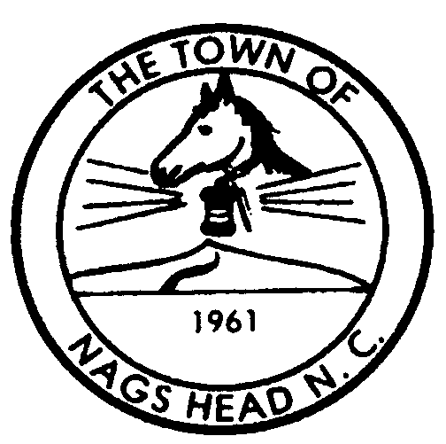
Town of Nags Head

Planning and Development Post Office Box 99 Telephone 252-441-7016
Department Nags Head, North Carolina 27959 FAX 252-441-4290
www.townofnagshead.net

MEMORANDUM

TO: Board of Commissioners
FROM: Planning Board and Planning and Development Staff
DATE: February 23, 2004
SUBJECT: Request for Public Hearing to amend Town Code Section 22-153 Definition of Specific Words and Terms and Section 22-254 (d) (1) pertaining to Flags and Flag Signs
At the August and October 2003 Planning Board meetings, Staff presented an ordinance amendment to regulate the size, height, and number of flags on commercial sites. Specifically, this amendment addressed non-commercial flags which can include governmental, organizational, religious, civic or other types of flags. Commercial flag signs were not included since these are already regulated in the ordinance.
Concerns were presented to Staff that these non-commercial flags, if flown at a size, scale, and number that is typically seen when trying to attract attention to commercial property, could negatively impact community appearance. The Town of Nags Head 2000 Land and Water Use Plan places great value on the visual and aesthetic resources of this area and recognizes that commercial development, ‘along with the signs, lights, noise, and other features which accompany such uses’, can deteriorate the quality of these resources if not managed properly. The Land and Water Use Plan also establishes objectives to preserve and enhance the appearance of the corridors within the Town. Staff is concerned that if the aforementioned use of flags is allowed to flourish in the commercial areas of Town, particularly along US 158 and NC 12, then this could exacerbate the appearance of over-commercialization town-wide.
The Planning Board, at their October meeting, discussed this ordinance but did not provide a recommendation to the Board of Commissioners. At that time, the Planning Board did not feel that flags present an aesthetic concern worthy of additional regulation. One major concern the Board had with the ordinance as presented was the limitation on the number of flags per site. Staff has re-drafted this ordinance amendment to focus more specifically on the size of flags that would be allowed and not necessarily the number of flags allowed per site. This would provide a basic regulation to prevent extremely large, ‘out of character’ flags, without creating flag non-conformities on existing commercial sites.
The attached ordinance creates a definition for non-commercial flags and limits the maximum flag size to 6’x10’.
Planning Board Recommendation

The Planning Board voted four to two to recommend approval of the attached ordinance amendment as presented. Planning Board members Bill Jones and Susie Walters cast the dissenting votes. Mr. Jones did not agree with regulations to limit the display of the U.S. Flag. Ms. Walters commented that the proposed ordinance was ambiguous and may not capture all situations for which it was intended to regulate.
DRAFT #2; 02/11/04; Staff
AN ORDINANCE AMENDING THE CODE OF ORDINANCES
OF THE TOWN OF NAGS HEAD, NORTH CAROLINA
BE IT ORDAINED by the Board of Commissioners of the Town of Nags Head, North Carolina, that the Code of Ordinances shall be amended as follows:
PART I. That Section 22-153 Definition of Specific Words and Terms be amended to include the following:

Flag Sign. A sign made of fabric, plastic, or similar material and displayed as a flag on a flag pole.

Sign. Any surface, fabric or device bearing lettered, pictorial or sculptured matter designed to convey information visually and exposed to public view, or any structures, including billboard or poster panel, designed to carry visual information.

(a) Bulletin board. A sign used to announce meetings or programs to be held on the premises of a church, school, auditorium, library, museum, community recreation center or similar noncommercial places of public assembly.

(b) Business sign. A sign which directs attention to a business, profession or industry located upon the premises where the sign is displayed, to type of products sold, manufactured or assembled, and/or to service or entertainment offered on said premises; but not a sign pertaining to the preceding if such activity is only minor and incidental to the principal use of the premises. Prior to the issuance of a certificate of completion a business sign may be erected on a premises provided a site plan has been approved by the town and the required building permit(s) has been issued.

(c) Construction sign. A sign used to advertise the general contractor, contractor, subcontractor, architect, landscape architect, or other such professional persons or organizations engaged in or associated with the lawful construction, alteration, remodeling or demolition of any building or use. The name, logo, symbol, or other printed expression of a business under construction may be included on the sign provided the expression is printed in accordance with subsection 22-254(c)(1)c.

(d) Directional sign. A sign which contains only the name of the establishment to which direction is given and directional information.

(e) Identification sign. A sign used to identify only: the name of the individual, family, organization or enterprise occupying the premises; the profession of the occupant; the name of the building on which the sign is displayed.

(f) Noncommercial sign. A sign structure designed and intended to promote, support, call attention to or give notice to a cause, nonprofit and noncommercial service, or political message of an individual, charitable organization, political group or other entity.

(g) Outdoor advertising sign and structure. A sign and structure which directs attention to a business, commodity, service or entertainment conducted, sold or offered:

1. Only elsewhere than upon the premises where the sign is displayed; or

- As a minor or incidental activity upon the premises where the sign is displayed

(h) Flag (non-advertising, non-informational). A piece of fabric or other flexible material attached to a freestanding flag pole or other permanent pole structure solely containing distinctive colors, patterns, standards, words, or emblems used as either a symbol of an organization or entity or as an ornamental feature, including but not limited to flags of the United States, North Carolina, county or municipal jurisdictions, foreign nations having diplomatic relations with the United States; flags of any religious, civic or fraternal organization, or any educational or cultural facility; and/or any other flags adopted or sanctioned by the Board of Commissioners. Flags shall be permitted in all districts on developed lots, provided that the following conditions are met:

- Such flags are displayed on permanent pole structures or other mounting surfaces.

- Flag poles shall not exceed thirty-five (35) feet in height above the road grade, except in accordance with Section 22-111 Exclusion from height limitations.

- The size of the Flag shall be no greater than six (6) feet by ten (10) feet.

  - Flag Sign. A sign made of fabric, plastic, or similar material and displayed as a flag on a flag pole. Flag signs shall not exceed twenty-four (24) square feet in area and thirty-five (35) feet in height above the road grade, and shall be allowed only on freestanding flag poles.

PART II. That Section 22-254 (d) (1) Signs permitted in the C-2, C-3, C-4 and CR districts b. 7. be amended to include the following:

7. One (1) flag sign shall be permitted in accordance with the specifications listed in the definition for flag sign as described in Section 22-153 Definition of specific words and terms. not to exceed twenty-four (24) square feet in area, thirty-five (35) feet in height above the road grade, and shall be allowed only on freestanding flag poles. The maximum freestanding signage shall not be increased in lieu of not flying a flag sign.
PART III. All ordinances or parts of ordinances in conflict with this ordinance are hereby repealed.
PART IV. This ordinance shall be in full force and effect from and after the ____ day of ___________, 2004.

Robert W. Muller, Mayor

ATTEST:

Town Clerk
APPROVED AS TO FORM:

Town Attorney
Date adopted:
Motion to adopt by Commissioner
Motion seconded by Commissioner
Vote: AYES NAYS

