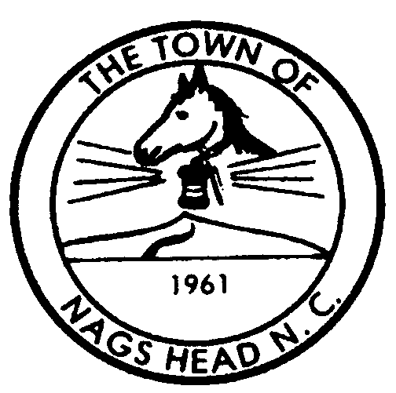
Town of Nags Head

Planning and Development Post Office Box 99 Telephone 252-441-7016
Department Nags Head, North Carolina 27959 FAX 252-441-4290
www.townofnagshead.net

MEMORANDUM

TO: Board of Commissioners
FROM: Planning and Development Staff
DATE: February 24, 2004
SUBJECT: Proposed Hotel Amendments – Suggested Land Use Plan Revision

Should the Board of Commissioners decide to adopt the proposed hotel ordinance amendments being presented at the March 3, 2004 meeting, Staff would suggest that the Board consider an amendment to the 2000 Town of Nags Head Land and Water Use Plan (LUP) pertaining to oceanfront access for hotels. This change would maintain consistency between the adopted zoning ordinance and the LUP.

Currently the LUP states that:

The Town requires and will continue to mandate that any non-oceanfront hotel or motel shall provide private oceanfront beach access facilities for their guests (Chapter 7, Beach Plan).

The proposed zoning ordinance amendment states that hotels between the highways must be within 300 feet of either a public or private ocean access but does not require the hotel to provide this access. Additionally, hotels west of US 158 must provide private, direct soundfront access. Therefore, Staff suggests the following LUP change:

The Town requires and will continue to mandate that any non-oceanfront hotel or motel east of US 158 or NC1243 shall be within a short walking distance of either a private-deeded oceanfront beach access or public beach ocean access facility. Hotels and motels west of US 158 and fronting on Roanoke Sound shall provide private on-site access to Roanoke Sound for their guests.

It is Staff’s opinion that any project which requires a CAMA permit that is not consistent with the adopted CAMA Land Use Plan could result in permit denial. Staff would urge the Board to consider this change to eliminate the possibility of CAMA permit denial for this reason.

