Public Works Department

Administration
Maintenance Garage
Sanitation
Public Facilities Maintenance
Water Distribution
Water Plant

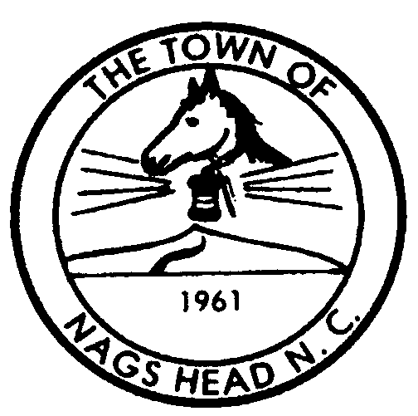

Town of Nags Head
Post Office Box 99
Nags Head, North Carolina 27959
Telephone (252) 441-1122
FAX (252) 441-3350
web: www.townofnagshead.net

MEMORANDUM

TO: Mayor and Board of Commissioners

FROM: Public Works Director

DATE: February 24, 2004

SUBJECT: Consideration of a Request to Apply for a Capacity Building Grant from the NC Rural Economic Development Center, Inc. for Engineering and Rate Studies to meet new Drinking Water Standards
…………………………………………………………………………………………….

On-going discussions with Dare County regarding the future use of the Town’s Fresh Pond Water Treatment Plant have resulted in the decision to continue to operate that facility to meet peak summer season demand for drinking water. To accomplish this goal, the Plant must be evaluated to determine its ability to meet short, and long, term changes (tightening) of Federal, and State, Drinking Water Regulations. The primary constituents affected in the next year are Turbidity and Total Organic Carbon (TOC).

The new turbidity standard of 0.3 NTU (turbidity units) becomes effective on January 14, 2005. With Fresh Pond “startup” normally occurring on July 1 each year, we actually have just over a year to come into compliance with this new standard. The existing limit on this component is 0.5 NTU, which we are able to meet with rare exceptions. In addition, with one exception, we were able to meet the 0.3 NTU standard throughout last year’s operating season. However, due to the exceptionally rainy winter and spring of 2003, we operated with a much higher water level in Fresh Pond than in previous years. This provided us with better quality untreated (raw) water, and therefore, a better quality finished water.

Right now, the TOC standards will require periodic monitoring that has not been required in the past. The problem with TOC is that above certain levels, it can combine with the Chlorine used for disinfection to create undesirable constituents in the processed water. To date, all samples from Fresh Pond have been well below current, or proposed, standards.

To determine what treatment enhancements may be necessary and most cost effective to meet the short, and long, term regulatory changes, we need to do an Engineering Study of

Rural Study Grant Application memo to the Board
February 24, 2004
Page 2

what we have in place, what it is capable of accomplishing and what additional treatment may be needed to meet these new standards. In addition, the financial aspects of the possible (construction of) additional treatment capabilities needs to be studied.

The North Carolina Rural Economic Development Center, Inc. (the Rural Center) has grant monies available for such engineering and rate studies for the expansion, or enhancement, of existing water treatment facilities. The Town’s water consulting engineer (Cavanaugh & Associates, P.A.) has agreed to prepare the necessary application for a grant in the amount of $27,000 at no cost to the Town. In order to increase the attractiveness of this application, the Town would agree to add $3,000 (a 10% share) to the grant to bring the total funds available for both studies to $30,000. The application deadline for 2004/2005 “Round 1” grants is March 31, 2004. If the Town’s application is successful, we would be notified in July of this year. Cavanaugh would then proceed with both studies to allow adequate time for decisions to be made and construction to take place.

Given the need to insure that the Fresh Pond Water Treatment Plant can continue to produce water that meets all drinking water standards for the foreseeable future, I would recommend authorizing the Mayor to sign all necessary documents as part of the application for a Capacity Building Grant from the Rural Center in the amount of $27,000. In addition, authorization of a 10% “match”, in the amount of $3,000 is recommended.

