Public Works Department

Administration
Maintenance Garage
Sanitation
Public Facilities Maintenance
Water Distribution
Water Plant

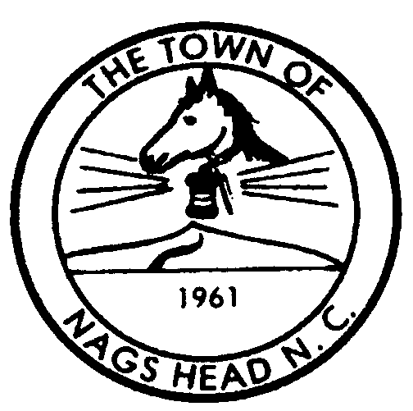

Town of Nags Head
Post Office Box 99
Nags Head, North Carolina 27959
Telephone (252) 441-1122
FAX (252) 441-3350
web: www.townofnagshead.net

MEMORANDUM

TO: Board of Commissioners

FROM: Public Works Department

DATE: February 23, 2004

SUBJECT: Requested Traffic Signal at Gull Street and US 158
…………………………………………………………………………………………….

The Public Works Department has received a copy of a letter from the General Manager of Tanger Outlet Center requesting that the town initiate a request to NC-DOT to install traffic signal lights at a re-configured center entrance to the mall. This new entrance would align with Gull Street on the east side of US 158. Public Works believes this would be an excellent solution to the current problem of left turning vehicles exiting the Mall at both the north, and south, entrances, and northbound traffic on US 158 making left hand turns into the mall. In spite of the “RIGHT TURN ONLY” signs that have been posted at both exits, these dangerous exit maneuvers are still taking place.

In conversations with representatives of NC-DOT, it has been made clear that the only place a signal light could be installed to serve Tanger Outlet Mall traffic would be at a new entrance constructed where the current stormwater channel is located. This new entrance would align with Gull Street and provide a justifiable “public” purpose for such a signal. Public Works supports this proposed new entrance and traffic signal.

