CUSTODIAL AGREEMENT

This CUSTODIAL AGREEMENT (“Agreement”) is entered into as of the ___ day of ______________, 2007 by and among FINISTAR, INC., a North Carolina corporation having its principal offices at 304 South Broad Street, Edenton, North Carolina 27932 (“Finistar”), Gateway Bank & Trust Co., a North Carolina Corporation having its principal offices at 1141 N. Road St. Elizabeth City, NC. 27909 (“Fiscal Agent”), and the Finance Officer of _________________, a “public unit” (“Public Depositor”).
WHEREAS, acting on its own behalf and as an agent for Public Depositor, Finistar is in the business of facilitating deposits of funds in financial institutions specified by Finistar (“Participating Banks”); and
WHEREAS, the transfers of such funds by Public Depositor to those Participating Banks require the custodial and fiduciary services of Fiscal Agent as described herein; and
WHEREAS, Finistar, Fiscal Agent and Public Depositor desire to set forth their respective rights and obligations in the aforesaid matters.
NOW, THEREFORE, the parties agree as follows:

Section 1. Appointment; Custodial Account: Master NOW Accounts. Finistar, acting as agent for Public Depositor and pursuant to instructions given by it, and Public Depositor hereby jointly appoint and retain Fiscal Agent, as a fiduciary, custodian and agent of Public Depositor within the meaning of Section 330.5 of the regulations promulgated by the Federal Deposit Insurance Corporation (“FDIC”), 12 C.F.R. § 330.5, to open and maintain a custodial account in the name of Public Depositor for receipts and disbursements of deposited funds of Public Depositor, which funds are considered “public funds” of a “public unit” described in Section 330.15 of the regulations promulgated by the FDIC, 12 C.F.R. § 330.15, and are required by applicable law to be either fully insured by a deposit insurance fund of the FDIC or collateralized as provided in Title 20, North Carolina Administrative Code, Chapter 7 (the “Custodial Account”). The Custodial Account shall be a negotiable order of withdrawal account. Fiscal Agent may utilize sub accounts of the Custodial Account as the custodial account for other public unit depositors within the State of North Carolina so long as the recordkeeping requirements of N.C. Gen. Stat. §159-31 and related regulations are satisfied as provided herein and the requirements for FDIC insurance of such deposits on a pass-through basis are satisfied as provided herein. With respect to each other public unit depositor, the Custodial Account shall be deemed to have been opened in the name of such depositor as to its proportionate share of the funds held therein. The funds of Public Depositor in the Custodial Account shall be fully covered by FDIC insurance or collateralized as described above. “Public Deposit Funds” as used herein includes all funds held in the Custodial Account from time to time and at any time for the benefit of Public Depositor.
Public Depositor hereby further jointly appoints and retains Finistar, acting as agent, and Fiscal Agent, acting as a fiduciary and agent, to open negotiable order of withdrawal accounts in the name of Fiscal Agent and on behalf of Public Depositor at Participating Banks pursuant to agreements between Finistar and such Participating Banks (each, a “Master NOW Account”).
Section 2. Funds; Receipts and Transfers. Fiscal Agent shall receive and disburse funds into and from the Custodial Account in accordance with the following procedures. Finistar shall give Fiscal Agent notice that a transfer of deposit funds (“Public Deposit Notice”) by Public Depositor to the Custodial Account via a federal funds wire or an ACH transaction (a “wire/ACH transaction”) is to occur and written instructions to transfer such Public Deposit Funds to Participating Banks designated as eligible for such transfer by Public Depositor (in a specified amount for each such Participating Bank) for deposit at each such Participating Bank (“Public Deposit Instructions”) in a Master NOW Account opened in the name of Fiscal Agent in its capacities established herein on behalf of Public Depositor. The forms of Public Deposit Notice and Public Deposit Instructions are attached hereto as Exhibits A and B, respectively, and are incorporated herein by reference.
All funds Received (as defined below) by Fiscal Agent on a weekday Fiscal Agent is open for the business of banking (a “Business Day”) shall be held by Fiscal Agent in the Custodial Account. Fiscal Agent shall give Finistar notice of its Receipt of each such deposit within one (1) hour of its occurrence (“Receipt Notice”). When Public Deposit Funds are held in the Custodial Account overnight they may accrue interest at the rate set forth in the Receipt Notice (which rate shall be agreed upon by Fiscal Agent, Finistar and Public Depositor from time to time). “Received”, “Receive” and “Receipt” shall mean the time that Public Deposit Funds are deemed to be “immediately available funds” to Fiscal Agent (if sent to Fiscal Agent via wire transfer) or “collected funds” of Fiscal Agent (upon the Fiscal Agent settlement date if transferred to Fiscal Agent via an ACH transaction). All Public Deposit Funds held in the Custodial Account, together with interest earned thereon, shall be transferred by Fiscal Agent to the eligible Participating Banks (and in the amounts, plus the applicable accrued interest thereon) designated in the Public Deposit Instructions prior to 3:30 o’clock, p.m., North Carolina time, on the same Business Day they are received. In the event that public deposit funds are not received by the Fiscal Agent within the designated times provided in the Public Deposit Instructions and are not transferred by Fiscal Agent to Participating Banks on the same business day they are received, they may be held in the custodial account overnight by Fiscal Agent and shall be promptly transferred (and in the amounts, plus the applicable accrued interest thereon) by Fiscal Agent to Participating Banks via wire/ACH transaction by 3:30 p.m. the next Business Day.

Section 3. Funds Withdrawals and Transfers. Fiscal Agent shall make withdrawals of funds (and/or interest earned thereon) held in Master NOW Accounts at Participating Banks and shall transfer such withdrawn funds and/or interest via wire/ACH transfer instructions to Public Depositor or pursuant to Section 6(a) in accordance with written instructions delivered by Finistar to Fiscal Agent (“Withdrawal/Transfer Instructions”). The form of Withdrawal/Transfer Instructions is attached hereto as Exhibit C and D and incorporated herein by reference. Finistar shall deliver to Fiscal Agent Withdrawal/Transfer Instructions pertaining to Public Depositor prior to 12:00 o’clock, p.m. on the Business Day on which Fiscal Agent is to make such withdrawal (all times stated herein are those in North Carolina). Funds (and interest thereon) of Public Depositor Received by Fiscal Agent prior to 1:00 o’clock, p.m., on such Business Day shall be consolidated, shall be held on deposit in the Custodial Account until transferred, and shall be transferred as instructed via a wire/ACH transaction by 4:00 o’clock, p.m., on that Business Day. Funds (and interest thereon) Received by Fiscal Agent after 1:00 o’clock, p.m., on such Business Day shall be held on deposit in the Custodial Account until transferred, and shall be transferred via a wire/ACH transaction promptly after Receipt by Fiscal Agent. In the event that Public Deposit Funds received by Fiscal Agent are not transferred to Public Depositor on the same Business Day they are received, such Public Deposit Funds shall be promptly transferred via a wire/ACH transaction by 4:00 o’clock, p.m., on the next Business Day. Such Public Deposit Funds shall accrue interest at the rate agreed upon by Finistar, Fiscal Agent and Public Depositor from time to time.

Section 4. Continuation of Deposits. Notwithstanding the provisions of Section 3 and Section 4 hereof and in conjunction with, or apart from, deposits of funds into the Custodial Account, withdrawals of Public Deposit Funds from the Custodial Account, and/or transfers of funds from Master NOW Accounts to the Custodial Account, Public Depositor may instruct Finistar to cause some or all of deposit funds (including some or all of the interest earned thereon) of Public Depositor held in a Master NOW Account (or in some or all applicable Master NOW Accounts), and being subject to withdrawal under the terms of the deposit of such deposit funds, to be re-deposited in such Master NOW Account or deposited in one or more Master NOW Accounts at other Participating Banks on such terms as are then existing (a “Continuation Notice” attached hereto as Exhibit E). Finistar shall provide to Fiscal Agent a copy of such Continuation Notice.

Section 5. Recordkeeping; Customer Information; Reconciling Funds. The recordkeeping obligations of Finistar and Fiscal Agent are as follow:
(a) Finistar. Finistar shall act as a third party record keeper with respect to deposit funds, and interest earned thereon, of Public Depositor. In this regard, it shall maintain (and provide to Public Depositor and/or Fiscal Agent upon request):
(i) Records of the name, address, taxpayer identification number of Public Depositor, and the name and contact information of the Public Depositor;
(ii) Records of the Public Deposit Notice regarding each transfer of Public Deposit Funds to Fiscal Agent by Public Depositor;
(iii) Records of the Public Deposit Instructions given to Fiscal Agent with respect to each transfer of Public Deposit Funds of Public Depositor by Fiscal Agent to eligible Participating Banks (including any interest earned thereon as a result of such Public Deposit Funds being placed in the Custodial Account);
(iv) Records of each Receipt Notice given by Fiscal Agent to Finistar;
(v) Records of Public Deposit Funds of Public Depositor held by Fiscal Agent in the Custodial Account and all interest earned thereon;
(vi) Records of each Master NOW Account maintained at each Participating Bank and Public Depositor’s proportionate interest in such Master NOW Account (and interest earned thereon);
(vii) Records of each withdrawal of Public Deposit Funds, and/or interest earned thereon, of Public Depositor from a Master NOW Account at a Participating Bank and the distribution thereof by Fiscal Agent to Public Depositor;
(viii) Records of each Continuation Notice given by Public Depositor to Finistar;
(ix) Records of each re-deposit of deposit funds of Public Depositor as provided in Section 4;
(x) Records of the aggregate amount of all funds of Public Depositor on deposit in the Custodial Account and the Master NOW Accounts;
(xi) Such other records as are necessary to cause Finistar, Fiscal Agent, Public Depositor and Participating Banks to comply with applicable laws and regulations.

(b) Fiscal Agent. Fiscal Agent shall:
(i) Maintain records of each Receipt by it of Public Deposit Funds from Public Depositor;
(ii) Maintain records of all Public Deposit Funds of Public Depositor deposited in the Custodial Account and of all interest earned thereon;
(iii) Maintain records of each transfer of Public Deposit Funds of Public Depositor, including interest earned thereon, to a Participating Bank;
(iv) Maintain records of each withdrawal of Public Deposit Funds, and/or interest earned thereon, of Public Depositor from a Master NOW Account at a Participating Bank and its distribution thereof to Public Depositor or as provided in Section 6(a);
- Records of each re-deposit of deposit funds of Public Depositor as provided in Section 4;
- Maintain such other records as are necessary to cause Finistar, Fiscal Agent, Public Depositor and Participating Banks to comply with applicable laws and regulations,
(vii) Provide confirmations to Finistar of each of its receipts of a Public Deposit Notice, Public Deposit Instruction, Continuation Notice or Withdrawal/Transfer Instructions;
(viii) Provide confirmations to Finistar of each of its transfers of Public Deposit Funds to Participating Banks and its compliance with the applicable Public Deposit Instructions;
(ix) Provide confirmations to Finistar of each of its withdrawals of Public Deposit Funds, and/or interest earned thereon, from Master NOW Accounts at Participating Banks, its distributions of the foregoing amounts to Public Depositor, and its compliance with the applicable Withdrawal/Transfer Instructions; and
(x) Receive requests for audit confirmations from the independent auditor of Public Depositor and provide appropriate audit confirmations to such independent auditor.
(c) Reconciliations. Finistar and Fiscal Agent shall reconcile their respective records of the Public Deposit Funds of Public Depositor transferred to Fiscal Agent; the Public Deposit Funds of Public Depositor transferred by Fiscal Agent to each Master NOW Account at each Participating Bank, including all interest earned thereon while such amounts were held on deposit by Fiscal Agent; and, the Public Deposit Funds, and interest earned thereon, of Public Depositor withdrawn by Fiscal Agent from each Master NOW Account at each Participating Bank and transferred by Fiscal Agent to Public Depositor or as otherwise provided in Section 6(a). Such reconciliation shall occur at least monthly, and may be required by Finistar or Fiscal Agent at any time if necessary to confirm the accuracy of the records maintained by Finistar or Fiscal Agent.

Section 6. Payments; Fees. The following payments shall be made to Finistar or Fiscal Agent:
(a) Finistar Fees. On or before the fifteenth Business Day of each calendar month, Finistar shall give Fiscal Agent Withdrawal/Transfer Instructions with regard to the Master NOW Accounts at the Participating Banks for purposes of this Section 6(a). No later than the twentieth Business Day of that calendar month, Fiscal Agent shall complete the instructed withdrawals and deposit the aggregate amount in a negotiable order of withdrawal account at Fiscal Agent maintained in the name of Finistar, acting as an agent for the Public Depositor (“Agent Account”). Thereafter, Finistar may instruct Fiscal Agent to make such transfers and/or other dispositions of such funds as Finistar and Public Depositor have agreed.
(b) Fiscal Agent Fees. On or before the tenth day of each calendar month, Fiscal Agent shall provide to Finistar a written invoice for services rendered by Fiscal Agent under this Agreement during the preceding calendar month. Fees invoiced by Fiscal Agent shall be calculated in accordance with the Schedule of Fees as agreed upon by Fiscal Agent and Finistar. As agent for Public Depositor, Finistar shall pay from the Agent Account such invoice on or before the last Business Day of the month in which it is received.

Section 7. Limitations; Exclusions. Finistar and Public Depositor agree that the obligations and liabilities of Fiscal Agent as fiduciary, custodian and agent under this Agreement are specifically limited or precluded as follows:
(a) Creditworthiness. Fiscal Agent shall have no obligation to investigate nor responsibility for the creditworthiness or financial condition of any Participating Bank in which a Master NOW Account is established.
(b) Reliance. Fiscal Agent may rely upon, without investigation or seeking the confirmation of Public Depositor, Public Deposit Instructions and Withdrawal/Transfer Instructions delivered by Finistar pursuant to this Agreement. Fiscal Agent may rely upon, without investigation or seeking the confirmation of Finistar, any other writing purporting to have been delivered by Finistar pursuant to this Agreement which contains verification codes agreed upon by Finistar and Fiscal Agent.
(c) Scope of Duties. Except for such duties and obligations as a depository bank imposed upon it under applicable federal and state laws, regulations and rules with respect to Public Deposit Funds held by it on deposit in the Custodial Account (collectively, “Depository Institution Laws”), Fiscal Agent shall be obligated to undertake only those duties and responsibilities as fiduciary, custodian and agent for Public Depositor that are expressly set forth in this Agreement, and no additional duties or responsibilities shall be deemed implied herein. Fiscal Agent shall not be required to take notice of, be bound by or act in response to any direction of Public Depositor or any Participating Bank (except, with respect to a Participating Bank, wire/ACH transfer instructions), but may rely upon Finistar, acting as agent for such persons and entities. Fiscal Agent shall have no duty or responsibility for approving any Participating Bank or for reviewing, engaging in due diligence with respect to, or verifying the accuracy of any sales or marketing literature or documents, agreements entered into by Finistar with Public Depositor or any Participating Bank, or similar documents or agreements.
(d) Standard of Care. Except as otherwise provided by Depository Institution Laws, Fiscal Agent shall only be liable for damages incurred by reason of its breach of this Agreement or its gross negligence or willful or reckless misconduct in the performance of its duties and responsibilities under this Agreement; provided, however, that Fiscal Agent shall in no event incur liability with respect to any action taken or omitted in good faith and reasonable reliance upon the advice of legal counsel given with respect to Fiscal Agent’s duties and responsibilities herein.

Section 8. Representations and Warranties. Finistar, Fiscal Agent, and Public Depositor as shown below, represents and warrants as follows:
(a) Finistar. Finistar represents and warrants to Fiscal Agent and Public Depositor that:
(i) It is a corporation duly organized, validly existing and in good standing under the laws of the State of North Carolina, has full power and authority to execute and deliver this Agreement and perform its obligations herein, and has received all corporate approvals necessary to execute and deliver this Agreement and to perform such obligations.
(ii) It is the duly authorized agent of Public Depositor for the purposes generally described herein;
(iii) No security interest created or permitted by Finistar exists with respect to Public Deposit Funds or any Master NOW Account;
(iv) No statement or representation, whether written or oral, has been or will be made to Public Depositor or any Participating Bank to the effect that Fiscal Agent has investigated the desirability or advisability of the business transactions generally described in this Agreement or to the effect that Fiscal Agent has approved, endorsed or passed upon the merits of such business transactions;
(v) It shall not use Fiscal Agent’s business name, or any variation thereof, in any press releases, advertisements, or marketing or sales literature or documents except to identify Fiscal Agent as the Fiscal Agent as contemplated by this Agreement; and
(vi) Its performance of its obligations under this Agreement do not violate its articles of incorporation or bylaws, any agreement to which it is a party, or any law or regulation applicable to the business transactions contemplated by this Agreement.
(b) Fiscal Agent. Fiscal Agent represents and warrants to Finistar and Public Depositor that:
(i) It is a corporation duly organized, validly existing and in good standing under the laws of the State of North Carolina, has fully power and authority to execute and deliver this Agreement and to perform its obligations hereunder, and has received all corporate approvals necessary to execute and deliver this Agreement and perform such obligations;
(ii) It has all regulatory authority and approvals under applicable banking laws, including trust or limited trust powers, necessary to execute and deliver this Agreement and to perform its obligations under this Agreement including the requirements for the collateralization of public deposits by exercising the pooling method as provided in Title 20 North Carolina Administrative Code, Chapter 7 ; and
(iii) Its performance of its obligations under this Agreement do not violate its articles of incorporation or bylaws; any agreement (including any memorandum of understanding, order, capital directive, prompt corrective action directive or any other similar regulatory instruction or requirement of, or other agreement with, any federal or state financial institution regulatory agency or other body); indenture; or similar contract or instrument.
- Public Depositor. Public Depositor represents and warrants to Finistar and Fiscal Agent that:
- It acknowledges that the rules and regulations of the FDIC require that the interests of the parties in an FDIC insured deposit account must be ascertainable either from the deposit account records of the insured depository institution or from records maintained, in good faith and in the regular course of business by some entity that has undertaken to maintain such records.
- It acknowledges that Finistar is designated as a third party record keeper with the responsibility of maintaining deposit records required by the FDIC to maintain insurance coverage of deposits held in deposit accounts at Participating Banks under this Agreement.
- It acknowledges that insurance of deposit accounts by the FDIC is a fact-based analysis under the rules and regulations of the FDIC, and that in certain circumstances, for example where an owner whose funds are deposited in an account has another account at the same FDIC insured financial institution with a total balance in both accounts of over $100,000, all or a portion of the funds in the accounts may not be insured by the FDIC.
- It will keep Finistar informed at all times of the name and location of each bank and other financial institution in the State of North Carolina with which it maintains a deposit relationship that is subject to FDIC insurance.
- In order to allow Finistar to fulfill its record-keeping responsibility as a third party record keeper, Public Depositor will provide to Finistar all necessary information with respect to all Public Deposit Funds and funds held in Master NOW Accounts as shall be reasonably necessary for Finistar’s activities under this Agreement (the “Sub-Account Records”). Public Depositor authorizes Finistar, in its capacity as Agent, to disclose the Sub-Account Records, if reasonably necessary in connection with the deposit of funds in the Master NOW Accounts or the maintenance of FDIC insurance of any such funds.
- The Public Deposit Funds deposited into the Custodial Account and all such deposit funds deposited into Master NOW Accounts at Participating Banks are eligible for deposit into negotiable order of withdrawal accounts.
- It acknowledges that Finistar and Fiscal Agent are not providing investment advice, are not acting as fiduciaries as defined in ERISA, and are not investment advisors under the Investment Advisor Act of 1940.

Section 9. Dispute Resolution. Finistar, Fiscal Agent and Public Depositor agree as follows:
(a) In the event of a disagreement between Finistar and Public Depositor or between Finistar and a Participating Bank (whether or not Public Depositor is a party to such dispute) that results in claims or demands being made in connection with or for funds of Public Depositor (including interest earned thereon) held in a Master NOW Account at a Participating Bank, Fiscal Agent may, at its election, either (i) maintain such funds (including all interest earned thereon) in the applicable Master NOW Account until it receives instructions of a court of competent jurisdiction or instructions agreed upon by Finistar and Public Depositor or Finistar, Public Depositor and such Participating Bank, as applicable, in each case directing Fiscal Agent to withdraw such funds (and all interest earned thereon) and specifying the parties to whom it shall transmit such funds (and interest) and the amounts to be transmitted, or (ii) withdraw such funds (including all interest earned thereon) and deposit them with any court (or clerk of court) having competent jurisdiction pursuant to such legal action as may be necessary or appropriate in the opinion of Fiscal Agent. Neither action shall deprive Fiscal Agent of its right to receive compensation earned by it prior to its transfer of the aforesaid funds. During the existence of any such disagreement or resulting legal action by Finistar, Public Depositor or a Participating Bank, Fiscal Agent may refuse to comply with the demands or instructions of any party to the disagreement.
(b) Finistar/Fiscal Agent Disputes. In the event of a disagreement between Finistar and Fiscal Agent (whether or not Public Depositor is a party to such dispute) that results in claims or demands being made in connection with or for funds of Public Depositor (including interest earned thereon) held in the Custodial Account or in a Master NOW Account at a Participating Bank, Public Depositor may require Fiscal Agent to either (i) maintain such funds (including all interest earned thereon) in the Custodial Account or the Master NOW Account, as applicable, for such time as Public Depositor shall specify, or (ii) withdraw such funds (including all interest earned thereon) and disburse them in accordance with Withdrawal/Transfer Instructions delivered by Finistar at the direction of Public Depositor and in compliance with this Agreement. Neither action shall deprive Fiscal Agent of its right to receive compensation earned by it prior to its transfer of the aforesaid funds.

Section 10. Indemnification. Finistar agrees to indemnify and hold harmless Fiscal Agent and its officers, directors, employees and agents (each, an “Indemnified Party”) from and against all losses, damages, costs, judgments, arbitration awards, liabilities and expenses, including reasonable attorneys’, accountants’ and investigators’ fees and expenses (collectively, “Damages”), arising or resulting from claims, claims for relief, actions, causes of action and similar legal proceedings (collectively, “Claims”) asserted against it, them or any of them by reason of (i) Finistar’s failure to perform its duties and responsibilities under this Agreement or (ii) Finistar’s breach of its duty to Public Depositor; provided, however, that Finistar shall have no such obligations with respect to Damages or Claims arising or resulting from or attributable to Fiscal Agent’s breach of this Agreement, violation of its duty to Public Depositor, violation of Depository Institution Laws, or from the gross negligence or willful or reckless misconduct of any Indemnified Person.
Within ten (10) days of their receipt of notice of the assertion of a Claim, the applicable Indemnified Parties shall give written notice thereof to Finistar. Finistar shall thereupon assume the investigation and defense of such Claim through legal counsel selected by it. In the event that Finistar is also a party to such Claim and its legal counsel concludes that there are one or more legal defenses available to the Indemnified Parties which such legal counsel may not assert in compliance with applicable rules of professional responsibility, the Indemnified Parties may engage separate legal counsel at Finistar’s expense and such legal counsel shall undertake the defense of the Indemnified Parties in such Claim.
The provisions of this Section 10 shall survive the termination or expiration of this Agreement.

Section 11. Termination. Either Finistar or Fiscal Agent, acting individually or in their applicable capacities herein, or Public Depositor may terminate this Agreement upon sixty (60) days prior written notice to the other parties. Additionally, in the event that a party materially breaches of any of its obligations hereunder and such breach remains uncured for ten (10) days after delivery of notice of breach by another party, the non-defaulting party delivering such notice may terminate this Agreement on the eleventh (11th) following the delivery of such notice. Notwithstanding the foregoing sentence and any termination of this Agreement pursuant thereto, until such time as all Public Deposit Funds held in the Custodial Account or all funds of Public Depositor held in Master NOW Accounts have been withdrawn and distributed by Fiscal Agent as provided in Sections 3 and 5(a), Finistar and Fiscal Agent shall continue to fulfill their respective obligations under Sections 1(a), 1(b), 2, 3, 4 and 6 until the distribution of all such funds (including, in each case, interest earned thereon) pursuant to Sections 3 and 6(a) is completed (the “Wind Down Period”). Fiscal Agent shall have no obligation to Receive Public Deposit Funds pursuant to Section 2(a) and 2(b) during the Wind Down Period.

Notices under this Section 11 shall be addressed as follows:
If to Finistar:
Finistar, Inc.
304 South Broad Street
Edenton, North Carolina 27932
Facsimile: (252) 482-8713
Attention: COO
If to Fiscal Agent:
Gateway Bank & Trust Co.
1145 N. Road St.
Elizabeth City, NC. 27909
Facsimile: 252-334-1511
Attention: CFO
If to Public Depositor:
________________________________
________________________________
________________________________
Facsimile: _______________________
Attention: _______________________
or to such other address as may be designated in a written notice delivered by one party to the others.
All notices under this Section 11 shall be in writing and delivered by U.S. mail, registered or certified, by hand delivery, by a nationally recognized courier service, or by confirmed facsimile. Delivery shall be deemed to have been made on the third business day following deposit in the U.S. mail, the next business day following receipt by overnight courier, upon hand delivery, and upon receipt of confirmation of a completed facsimile transmission.

Section 12. Delivery of Notices and Instructions. All Public Deposit Notices, Public Deposit Instructions, Receipt Notices and Withdrawal/Transfer Instructions shall be originated through and confirmed through the appropriate interface provided by Finistar as described in Exhibits A, B, C and D and shall be designated as written notice delivered by one party to the others as provided in this Section 12. Delivery shall be deemed made upon receipt of confirmation of the electronic notification.

Section 13. Complete Agreement; Amendment. Except for the obligations and rights of Finistar and Public Depositor set forth in the Depositor Agreement between them, this Agreement sets forth the complete agreement of Finistar, Fiscal Agent and Public Depositor with respect to the subject hereof and supersedes all prior agreements, understandings, agreements in principle and discussions between them with respect to such subject matter. Except as specifically provided with respect to changes of addresses, this Agreement may not be altered, modified or amended except pursuant to a writing executed and delivered by Finistar, Fiscal Agent and Public Depositor.

Section 14. Governing Law; No Assignment. This Agreement is made in, shall be governed by, and shall be construed under the laws of the State of North Carolina. Neither Finistar, Fiscal Agent nor Public Depositor may assign or delegate (other than by operation of law pursuant to a merger) its rights, responsibilities or duties under this Agreement.

Section 15. Confidentiality. Fiscal Agent and Public Depositor agree that the structure, format and procedures of the business transactions contemplated by this Agreement, and that the inventions, trade secrets, know-how, designs, processes, formulae, customer lists, Participating Bank lists, software and other information and intellectual property utilized by Finistar in connection with the foregoing (whether in writing or in a form from which such information or intellectual property can be obtained, translated or derived in a reasonably usable written form), constitute confidential and proprietary information and trade secrets (“Confidential Information”) of Finistar. Fiscal Agent and Public Depositor each agrees that it shall not disclose any Confidential Information to any third party except pursuant to a subpoena or other legal process of a court of competent jurisdiction, and Fiscal Agent further agrees that it shall use or permit the use of Confidential Information or any derivation thereof solely in performance of its duties and responsibilities under this Agreement.

IN WITNESS WHEREOF, the parties hereto have caused this Custodial Agreement to be executed and delivered as of the date first set forth above.

FINISTAR, INC. (Agent)

By: ______________________________________

Name: ____________________________________

Title: _____________________________________

Gateway Bank & Trust Co. (Fiscal Agent)

By:_______________________________________

Name: ____________________________________

Title: _____________________________________

__________________________ (Public Depositor)

By: ______________________________________

Name: ____________________________________
Title: Finance Officer

Exhibit A
Deposit Notification exhibits for Public Depositor and Fiscal Agent Notification

Written Public Deposit Notifications to the Public Depositor and Fiscal Agent will be considered fulfilled by a registered user of the Public Depositor Finistar system completing the following two screens by “Submitted” Screen #1 and “Accepted” Screen #2 by 12:00 PM, North Carolina time, for transaction to be posted same Business Day:

Screen #1

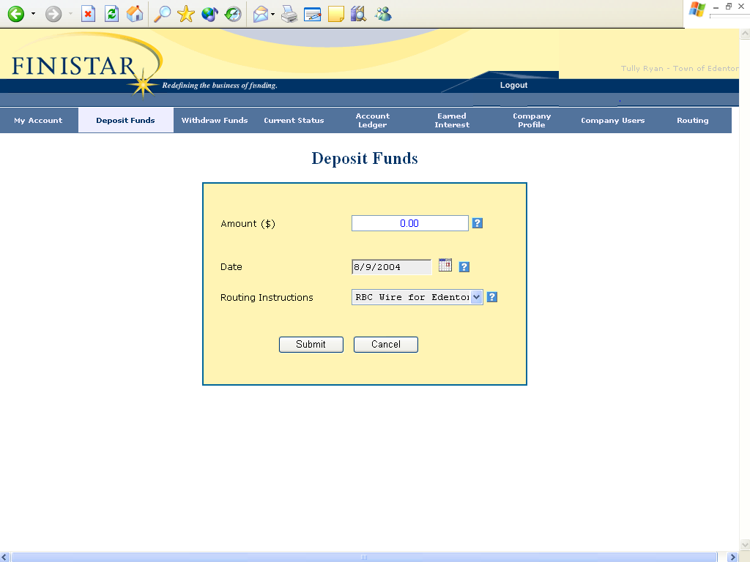

Screen #2

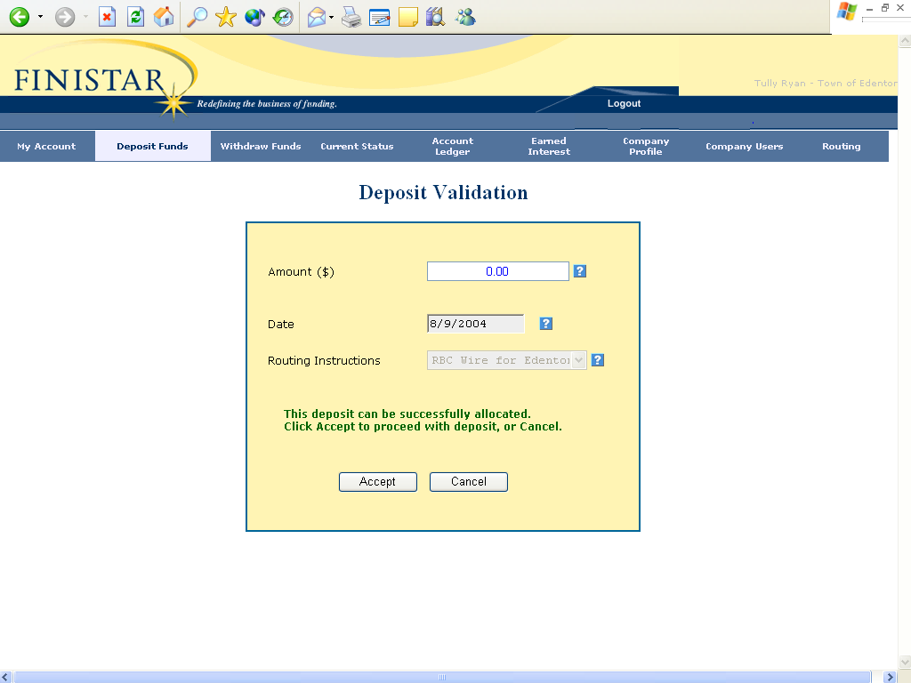

Exhibit B
Deposit Instructions for Public Depositor and Fiscal Agent

Public Deposit Notice will be sent electronically via e-mail to all users as registered in the Finistar system under the Public Depositor and Fiscal Agent. Notification e-mails will contain the following for all deposit requests and confirmations of received wires:

- Public Depositor Deposit Instructions (E-mail sent to all registered users of the Public Depositor Finistar system once Public Depositor user completes Public Deposit Notice process as described in Exhibit A)
  - Amount of scheduled deposit
  - Wire instructions (Fiscal Agent wire instructions)
  - Message: Funds must be wired today and received by Fiscal Agent by 1:00 p.m., North Carolina time, for transfer to a Master NOW Account at a Participating Bank on the same Business Day.
- Fiscal Agent Deposit Instructions (E-mail sent to all users of Fiscal Agent’s Finistar system once Public Depositor user completes Public Deposit Notice process as described in Exhibit A)
  - Amount of scheduled deposit
  - Wire instructions (depositor wire instructions)
  - Message: Funds must be received by 1:00 p.m., North Carolina time, today [date] for same Business Day transfer to a Master NOW Account at a Participating Bank.
- Public Depositor Deposit Confirmation (E-mail sent once Fiscal Agent acknowledges receipt of in-bound wire from Public Depositor)
  - The Fiscal Agent has received your deposit of [deposit_amount] and will credit your account on [date] for interest calculations. Thank you for using Finistar your premier cash management solution. If you have any questions please call us at 877-346-4782.
Exhibit C
Withdrawal/Transfer Notification for Public Depositor and Fiscal Agent

Written Withdrawal Notifications to the Public Depositor and Withdrawal Notification Fiscal Agent will be considered fulfilled by a registered user of the Public Depositor’s Finistar system completing the following two screens by “Submitted” Screen #1 and “Accepted” Screen #2 by 12:00 PM, North Carolina Time, for transaction to be posted same Business Day:

Screen #1

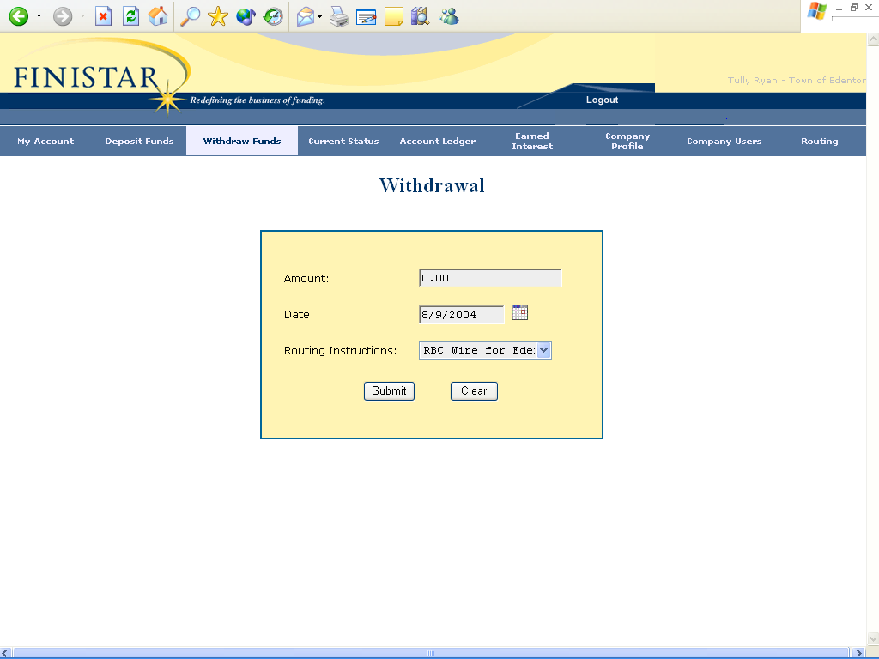
Screen #2

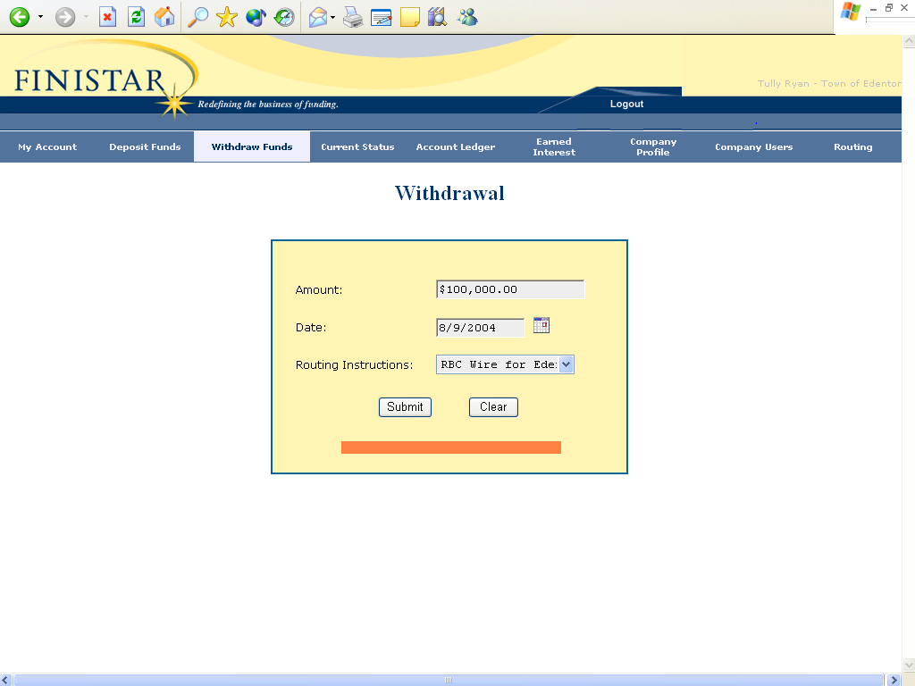
Exhibit D
Withdrawal Instructions for Public Depositor and Fiscal Agent

- Public Depositor Withdrawal Instructions (E-mail sent to all registered users of the Public Depositor’s Finistar system once Public Depositor user completes Withdrawal/Transfer Notification process as described in Exhibit C)
  - Amount of withdrawal
  - Funds will be wired by 4:00 p.m., North Carolina Time, [date] to: Public Depositor’s wire instructions
- Fiscal Agent Withdrawal Notification (E-mail sent to all users of Fiscal Agent’s Finistar system once Public Depositor user completes Withdrawal/Transfer Notification process as described in Exhibit C)
  - Amount of withdrawal
  - Wire instructions (Public Depositor wire instructions)
  - Message: Funds must be wired by 4:00 p.m., North Carolina Time, today [date] to the above described wire instructions
- Public Depositor Withdrawal Confirmation (E-mail sent once Fiscal Agent acknowledges sending of out-bound wire to Public Depositor wire instructions)
  - Finistar has received your withdrawal request and Fiscal Agent has wired [withdrawal_amount] to [Public Depositor wire instructions]. Thank you for using Finistar your premier cash management solution. If you have any questions please call us at 877-346-4782.

Exhibit E
Continuation Notice

It should be noted by all parties the following shall apply:
1. All interest and principal shall be re-deposited in a Master NOW Accounts at Participating Banks, absent contrary instructions for the Public Depositor.

2. If a Public Depositor wishes to withdraw interest and/or principal, this shall be accomplished in accordance with Section 3 of the Custodial Agreement.

3. Public Depositor authorizes Finistar and Fiscal Agent to re-deposit Public Deposit Funds and interest earned thereon upon the expiration of each relevant term of deposit and to re-allocate such Public Deposit Funds and interest among Master NOW Accounts as provided in the Custodial Agreement.

