Administration 1
Administrative Services 6
Accounting and Collections 6
Human Resources 7
Information Technology 8
Planning and Development 10
Planning/Zoning 10
Septic Health Initiative 14
Building Inspections 15
Public Safety 20
Police Division 20
Fire and Rescue Division 29
Public Works 33
Public Works Administration 33
Fleet Maintenance 34
Public Facilities Maintenance 35
Sanitation 36
Water Distribution 37
Water Operations 38

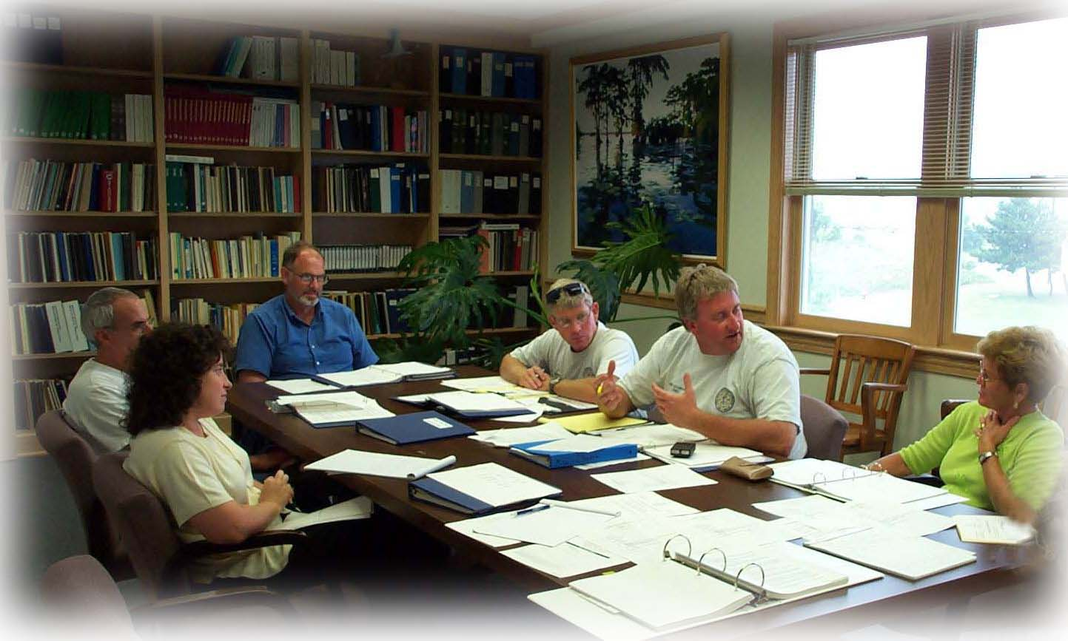
Administration
The overall functions of this department include maintaining and safeguarding official Town records, providing access to official Town records for Town departments, elected officials, and citizens, and providing public notice of official meetings. In addition, the Administration Department provides administrative support for the Board of Commissioners, Town Manager, and all Board-appointed committees. Finally, this department issues broadcasts/media releases to the media and public and provides support to the Town and Dare County during emergency events via participation in the Joint Information Section.

The goals of the Administration Department include managing Town records efficiently to provide central resource facility for quick and easy access by all Town departments, elected officials, and citizens. In addition, the department provides support for the Board of Commissioners, Town Manager, residents/visitors and other Town departments. Automating the indexing in the Clerk’s Office to facilitate access to permanent Town records by all departments through the shared drive on the Town computer system is a department goal along with providing access to certain Town records on the Town’s web site to include Board of Commissioners meeting agendas, backup materials, summary actions, public notices, resolutions, ordinances, and approved minutes. Finally, Administration strives to release items of interest in a timely manner to the media and the general public and perform as the link between the Town and the County via the public information officer.

Board/Committee Meetings, Agendas, Minutes, Public Notices - Objectives
- Prepare and distribute agendas, summary actions, and formal minutes of the Board of Commissioners meetings
- Prepare and distribute agendas and formal minutes of Town Board/Committee meetings, various ad hoc committees, and specialized meetings as requested
- Prepare and distribute minutes of weekly staff meetings
- Provide adequate public notice of Town board/committee meetings, retreats, public hearings, and events; maintain current Town Board/Committee meeting schedules
- Utilize Board of Commissioners paperless agenda process through use of the Town’s web site

Supporting Information
- Twenty Board of Commissioners meetings; 19 persons on Sunshine List notified
- Meeting agendas published and posted
- Thirty–eight public hearings advertised
- Board actions/formal minutes prepared for each Board meeting and posted on web site
- Board closed session formal minutes reviewed/opened annually as appropriate by Board
- Formal Board minutes filled 286 legal pages
- Minutes were prepared and distributed for 27 staff meetings
- Agendas, minutes and reports prepared for three Citizens Advisory Committee (CAC) meetings
- Citizens Advisory Committee annual awards (Commercial Community Appearance Award, Residential Architecture Award, and Nags Head Lightkeeper Award) distributed, Committee work updated on Town web site
- One hundred eighty Board packages coordinated, organized, and distributed

Town Code, Ordinances, Resolutions, Proclamations and Policies - Objectives
- Process ordinances, resolutions, proclamations, and policies
- Maintain current Town Code of Ordinances
- Prepare and distribute updates to the following Town documentation: Town Code, Consolidated Fee Schedule, Committee/Board rosters, Policy Book, and Record Retention Schedule
- Provide access to the Town Code, ordinances, resolutions, proclamations, and Consolidated Fee Schedule via web site

Supporting Information
Adopted, processed, and distributed by this office during Fiscal Year 2008 - 2009:

- Forty-three ordinances
- Thirty-two resolutions
- Three proclamations
- Four Town Code Supplements
- Forward detailed calendar to Board of Commissioners first of each month

Permits, Applications, Meeting Room Reservations - Objectives
- Process permit applications for outdoor crowd gathering events, bonafide fishing tournaments, closing-out sales, massage therapy businesses, massage therapists, and taxi-cab businesses
- Establish Town Park (Harvey Sound Site and Barnes Street) reservations for residents/visitors; coordinate special requests as necessary; reserve/coordinate special requests for Board Room, Library, and Admin Conference Room
- Procure and return as necessary the clean-up deposits required for Town Parks and Board Room; utilize Town policy for priority reservations of the Board Room

Supporting Information
- Processes 44 Town Park reservations
- Scheduled Board Room for meeting location, maintained supplies/room setup
- Processed 28 Outdoor Crowd Gathering Applications
- Processed 282 temporary beach driving permits for Nags Head Surf Fishing Tournament
- Processed two taxi-cab business applications

Records Management - Objective
- Safeguard and maintain the Town's official permanent records, i.e., deeds, contracts, memorandums of understanding, agreements, minutes, ordinances, resolutions, proclamations, etc. for history and research by all Town departments, elected officials, and citizens

Supporting Information
- Ordinances, resolutions, proclamations, and minutes filed in permanent books - stored in fire-resistant vault
- Contracts/agreements/MOU's/MOA's stored in vault; indexed on shared drive for easy retrieval
- Approximately 54 contracts/agreements/deeds were processed during Fiscal Year 2008 - 2009
- Emergency evacuation box provided to the fire chief/emergency manager during times of emergency and updated annually, prior to the start of the hurricane season

Research - Objective
- Research Town records in an efficient and timely manner in response to requests for information

Supporting Information
- Researched numerous inquiries/requests from other Town departments, the general public\Board members concerning Board agendas, past Board meeting minutes, historical data, legal issues, etc.

Bids, Certifications, Oaths, Etc. - Objectives
- Coordinate the formal bid process
- Attest all official documents for the Town; notarize/certify documents when requested/required
- Administer all oaths of office

Supporting Information
- Processed formal bid openings to include advertisement, vendor letters, security deposit
- Utilized GovDeals online auction web site for sale of surplus Town equipment
- Certified, attested, and notarized numerous documents from citizens, departments, Board members
- Public Safety Oath was administered to one new police officer

Public Information Officer - Objectives
- Notify/release information to the general public and the media concerning newsworthy events; respond to various media inquiries
- Disseminate accurate information regarding emergencies and other Town-related information
- Participate in Dare County Joint Information Section

Supporting Information
- Prepared/forwarded 43 media/news releases
- Distributed 80 email broadcasts
- Updated/maintained the Town web site home page to include all pertinent emergency information
- Participated in Dare County Joint Information Section, which allows the Town to remain current with storm procedures before/during/after an event as well as general items of interest to Town residents and visitors

Town Web site (www.townofnagshead.net) - Objectives
- Provide and maintain useful information on the Town’s web site; provide user-friendly access to pertinent information
- Update and maintain Town web site’s home page
- Respond to all web site inquiries or refer to appropriate department for timely response

Supporting Information
- Agendas, backup, actions, minutes, etc. for Board meetings/retreats - provided on Town’s web site
- News items of interest are posted on the web site home page
- Notices of public hearings, notices, bid openings are maintained on the Town’s web site
- Board meetings are aired live via web site; Board meetings are replayed four separate times Friday/Saturday following the meeting on government access channel
- Each Town Board/Committee has web page with application to serve included
- Town Clerk’s office receives public inquiries/comments/etc. that are submitted via web site; inquiries are answered by the clerk or are forwarded to appropriate department for response

Highlights/Accomplishments Fiscal Year 2008 - 2009
- Town Celebrations - Coordinated Veterans Day and Memorial Day celebrations in support of nation's military; began preliminary discussions of June 14, 2011 Town 50th Birthday celebration; assisted in coordination of annual Bike and Build bicyclist kickoff ceremony in support of affordable housing; celebrated Town birthday on June 14th, awarded residential architectural/commercial architectural/Town Lightkeeper awards
- Town web site inquiries – Responded promptly to inquiries and, if necessary, distributed Town inquiries for appropriate departmental response
- Town web site (Home Page) –Maintained Home/Front page "News & Information" to include easy access to latest Board meeting agenda/backup as well as items of specific interest, i.e., public hearings concerning “hot” topics such as beach nourishment, upcoming storm events, etc.
- Town web site - Updated web site to include Board adopted resolutions
- Email Broadcast – Distributed weekly email broadcasts to transmit messages of interest, i.e., ocean rescue information, street paving schedule, street closures, weather information, water flushing schedules, etc. to those registered for the email broadcast
- Frequently Asked Questions (FAQ) on web site – Expanded frequently asked questions on web site to include information on weddings/receptions on the beach, outdoor crowd gathering events
- Traffic Control Map – Began work on an in-house automation of the Town’s traffic control map

Goals Fiscal Year 2009 - 2010
- Town web site - Continue to customize Town web site by providing current information, such as the FAQ section, to benefit residents and visitors so that better information results in fewer inquiries
- Library - Organize Town Library to make it more useful; include areas for beach nourishment resources, individual departmental information, specify section for general statutes, finance, etc.
- Update Contracts Directory – Update the contracts directory on the shared access drive in the Town Clerk directory with hyperlinks to actual document copy
- Document Imaging - Research document imaging technology to determine benefit to office procedures
- Research - Research new verbiage - Employee/Citizen Certificates of Appreciation/Recognition
- Traffic Control Map – Continue to work toward an in-house automated traffic control map via incorporation into the Town’s GIS
- Paperless agendas - Efforts continue toward paperless Board agendas/backup for Board members
- Provide Closed Session Minutes – Provide closed session minutes for Board of Commissioners review/release twice yearly, rather than once a year


Administrative Services
The Administrative Services department provides continuous support for all of the other Town departments in the areas of human resources and accounting and collection matters. Further, the department safeguards the assets of the Town by implementing and maintaining internal controls and the Town’s investment policy.
The reorganization of the department continued with reallocation of duties between personnel, shifts of personnel between positions, and ongoing cross training for backup of positions and responsibilities, culminating with the upgrade of two positions with the adoption of the Fiscal Year 2007-2008 budget. Included changes were reassignment of payroll processing, reassignment of central purchasing and supplies inventory, full time responsibility for central cashier position duties, and backup training for water billing and collections and tax billing and collections.

Accounting and Collections
The Administrative Services department plays a key role in the preparation of the annual operating and the capital improvement budgets. Centralized purchasing allows for the timely identification of budget issues so that they can be addressed. This department monitored spending closely and brought forward 14 budget amendments, which included 61 adjustments in Fiscal Year 2008-2009. There were 3,076 accounts payable checks issued during the fiscal year and $2,308,99, down from $3,535.46, was saved by taking advantage of purchase discounts. We also initiated payment by ACH and made an additional 660 vendor payments electronically saving the cost of both checks and postage up from 151 last fiscal year. In addition credit card payments of $70,248 were processed and allocated to the appropriate expenditure account compared to $79,055 during the prior fiscal year. There were 97 new vendor files established bringing the total vendor files to 2.685 excluding temporary customer repayment vendors. There were 1,040 purchase orders issued and 63 federal tax form 1099’s were prepared for the year. Through monthly sales and use tax reporting and the annual sales and use tax report the Town was able to receive back from the state $55,576 from sales and use taxes paid compared with $69,735 in the prior year.

To maximize investment earnings and minimize risk the investment pool was further diversified during the year to include the investment of funds in Finistar and increase the amount invested in large certificates of deposit with BB&T and RBC. This diversification of invested funds helped somewhat to offset the decline in market interest rates which resulted in reduced investment earnings for the Town to $410,871 from $685,258 in the prior fiscal year. Rates earned on short term funds invested in NCCMT fell from 2.52% in July 2008 to .57% in June 2009 compared to rates of 2.35% to 4.0% earned on the larger longer term certificates of deposit throughout the full fiscal year.

The Town maintained a 99.65% tax collection rate (unaudited) for the fiscal year ending June 2009. This represents a slight decrease from our prior year collection rate of 99.96%. The breakdown includes a collection rate of 94.69% for DMV and 99.71% for advalorem taxes. There were 6,061 tax bills issued, 1,700 late tax notices (up from 484 due to sending them in December in advance of past due date), and 39 uses of enhanced collection methods including bank and rent attachments and one initiation of the in rem foreclosure process. There were 1,286 privilege licenses issued (versus 1,131 the prior year).

Water encountered another busy year as well with 28,272 water bills processed, 2,950 second notices and 221 cut-off tags prepared (up slightly from 203). We also continued making courtesy phone calls to each customer prior to cut off of water service. There were 15 new water service accounts (up from 7) and 130 accounts were final billed and transferred to new owners. There were 49 Septic Health credits processed of the 58 issued. Our total active water accounts at June 30, 2009 were 4,709 (including 4,321 residential). During the year, 216 adjustments were made to water accounts. The water billing policy that went into effect in 2002 continues to help with efficiencies of collections and tenant accounts. We began billing the new storm water fee of $4 per water bill in March of 2005 with total revenues of $36,776 for the year ended June 30, 2005, $110,796 for the year ended June 30, 2006, $111,720 for the year ended June 30, 2007, $112,378 for the year ended June 30, 2008, and additional revenues of $112,368 for the year ended June 30, 2009.

An unqualified (clean) opinion was received from our auditors Martin Starnes & Associates on the Town’s financial statements for the previous fiscal year in the second year of a three year contract for audit services.

This past year 14 workers compensation claims were filed representing $63,050 in total costs and 131 lost work days compared with the prior years 11 claims with $9,472 in total cost and 16 lost work days. We also facilitated 10 incident/damage claims totaling $28,839. Administrative services also provided support for grants and land transactions.

Human Resources
There were 4 full time vacancies advertised for the various departments in 2008-2009 and a total of $493 was spent on advertising those vacancies. New employee orientations and processing was conducted for 4 full time employees and 41 part time employees. The average turnover rate for the year was 11% with an average of two months time to fill a vacant position. Seven positions remained vacant and frozen as of the end of the fiscal year. There were also 1 promotion, 6 resignations, 3 retirements processed, and one fatality. There were 731 payroll checks issued in 2008-2009 along with 3,078 direct deposit advices. A total of $19,835 was paid for unemployment costs, up from the prior year of $15,064 but not at the highest level of $26,439 paid in 2005-2006. There were 5 notices of potential unemployment claims processed with 2 phone hearings held. The average cost expended to hire a new general employee was $525; $3,855 for a firefighter; $3,288 for a police officer and $1,325 for a Public Works employee. The variations here are mostly attributed to the initial uniform and equipment costs.

Since its inception, the Board adopted Employee Computer Lease/Purchase Program has been well received. There were 249 computer loans processed in this program to-date with 18 new loans in 2008-2009, totaling $25,945. A cumulative total of $418,856 has been loaned under this program. The total amount outstanding at 6/30/09 was $33,897. As part of the Town’s commitment to its employees, the funds expended for training amounted to an average of $155 per employee for Fiscal Year 2008-2009, down from $522 per employee in 2007-2008. In addition, there were 27 participants in the Town’s career development program with $29,486 of costs incurred for training and the related travel and supplies. Neither the career development nor the computer loan program received funding for Fiscal Year 2009-2010.


Information Technology

Equipment Deployment
- A Cybernetics Storage Area Network (SAN) appliance was purchased in May. This unit will provide 750 GB of additional data storage space for the Town.
- A Barracuda Message Archiver 350 was purchased in May also. This appliance captures and stores emails for archiving and easy retrieval. The archived emails are fully searchable and retrievable to comply with public records and e-discovery requests. Employee’s archive email files will be migrated to this unit also if space allows.
- Three Blackberry mobile devices were purchased and deployed in Fiscal Year 2008-2009. The Town was given the Blackberry Enterprise Server (BES) software with the purchase of these devices. An older server was reclaimed from surplus and commissioned for use as the BES.
- Eight desktop and 17 laptop computers were purchased and deployed.

Equipment Supported – Fiscal Year End
Telephone Equipment | Network Infrastructure
3 telephone systems | 2 Firewalls
108 telephone sets | 1 Spam Firewall
 | 1 Router/CSU/DSU
Storage | 12 Fiber Converters
1 Email Archiver | 12 Managed Switches
1 SAN | 6 Wireless Access Points
 | 4 Wireless Backhaul Points
Computers and Printers
9 Servers | Cellular
59 Workstations | 45 Cell Phones
39 Laptops | 3 Blackberrys
36 Printers | 11 Air Cards

Employee Lease Purchases
The IT Department reviewed and processed 18 Employee Lease Purchase Agreements totaling $25,945.12 in Fiscal Year 2008-2009.

Town Hall Phone System Utilization
A total of 140,808 calls were recorded to and from that Nags Head Town Hall phone system during Fiscal Year 2008-2009. The total number of calls per business day for Fiscal Year 2008-2009 is approximately 521. This is based on being open for business 251 days in Fiscal Year 2008-2009 with an average of 89 calls per day when closed. Approximately half of the phone calls originated from outside of the system (70,662) and half were initiated by Town staff. The spike in call volume that began on May 15th, 2009 was due to the death of Nags Head Police Sergeant Earl Murray.

(Note: The call logging software does not count extension to extension calls. Also, we do not have call logging systems installed for the Public Works phone system, Ocean Rescue Station 20, and Fire Station 21. Calls to and from these locations, except for calls to and from Town Hall, are not included in the log files. Fire Station 16 is serviced by the Town Hall system and calls to and from this location are included in the log reports.)

Total Phone Calls through the Town Hall Phone System Fiscal Year 2008-2009

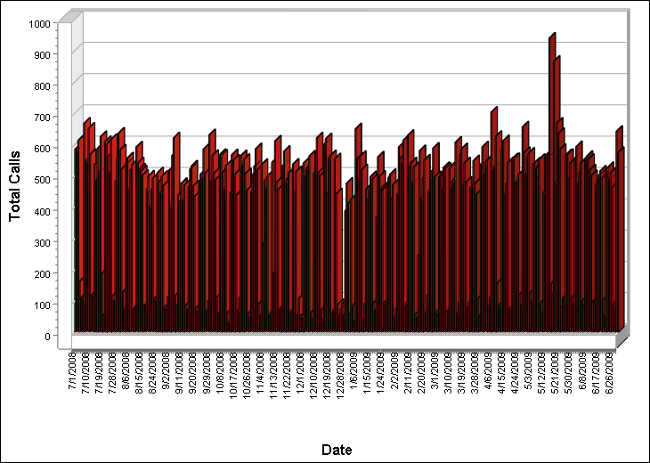

Total phone calls to and from the Town Hall phone system have steadily decreased over the past 5 years. (Hurricane Isabel was responsible for an unusually high call volume in Fiscal Year 2003-2004.) The IT Coordinator attributes this trend to increased utilization of wireless and broadband communications services (cell phone and Internet communications).

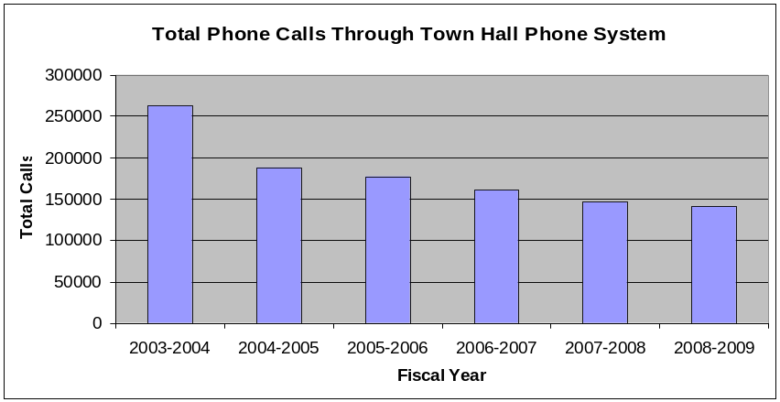



Planning and Development

Planning/Zoning

Land and Water Use Plan Update
Phase II of the 2006 Land and Water Use Plan resumed in the fall of 2007 with policy development as the primary focus. During Fiscal Year 2007-2008, staff met with the Board of Commissioners and Planning Board to review and revise the policy section of Phase II. The comments were incorporated and the plan was submitted to the Division of Coastal Management (DCM) in June of 2008. On July 1, 2008 the Town was notified by DCM that additional information was needed before the routing of the draft plan to state agencies for review. Staff revised the plan and it was then routed to State agencies for review the week of August 4, 2008. In October of 2008 staff received CAMA and other State agency comments on the plan. The plan was revised per the state agency comments and resubmitted to CAMA in February 2009. The Town is awaiting CAMA’s final review of the Plan.

Parks and Recreation Plan
In June 2009 the Board of Commissioners approved a Parks and Recreation Plan survey. The survey will be used to develop a Parks and Recreation plan, which will make the Town more competitive in receiving future grant funds, as well as give the Board of Commissioners guidance in developing the Town’s recreational opportunities. Approximately 4,500 surveys will be mailed to Town property owners by September 30, 2009.

Grants

Division of Coastal Management Public Beach and Coastal Waterfront Access Program
Staff also completed a Division of Coastal Management (DCM) Public Beach and Coastal Waterfront Access Program. The grant request was for the construction of a bath house on the Jennette’s pier property. In May 2009, the Town requested $130,000.00 from DCM. In July 2009 the Town was notified it was awarded the full grant request.

North Carolina Rural Center
In early January 2008, staff submitted a pre-application for funding eligibility for the North Carolina Rural Center’s North Carolina Economic Infrastructure Program grant. The Town requested $1 million to help fund a grey water reuse wastewater treatment and disposal facility for the North Carolina Aquarium at Jennette’s Pier project. On February 21, 2008 the North Carolina Rural Center invited the Town to submit a full application. The amount of funds awarded was $500,000 and the Town’s match was $50,000. The deadline for the full application was August 22, 2008. In July 2009 DENR and the NC Aquarium requested that the Town not pursue the grant.

Overview of New and Amended Zoning Regulations
This fiscal year the Board of Commissioners heard 24 proposed zoning ordinance text amendments. Below is a sampling of the amendments.

Text Amendment to Town Code Section 48-87(b), Prohibitions
Town Code Section 48-87(b), Prohibitions, was amended at the Board of Commissioners August 6, 2008 meeting to reduce the maximum size allowed for retail buildings within the Town of Nags Head from 50,000 square feet to 40,000 square feet. This text amendment was initiated by the Board of Commissioners.

Text Amendment to Town Code Section 48-405, Fishing Piers as a Conditional Use within the CR, Commercial Residential Zoning District and Town Code Section 48-167, Required Parking by Use
Town Code Section 48-405(c)(1) was amended to permit a pier house to have multiple accessory or principal uses, to permit the maximum height of the pier house structure not to exceed 60 feet, to permit accessory wind turbines with a maximum height of 105 feet from ground elevation or the deck or the deck of the pier, to allow an increase in lot coverage of up to 60% when open-face paving block is used and to permit off-site wastewater treatment facilities and parking. Town Code Section 48-167(5), Required Parking by Use, Indoor Public Assembly was amended so that when indoor public assembly is permitted in conjunction with fishing pier use, one parking space per 55 square feet of customer area shall be required. These amendments were requested and approved prior to beginning construction of the NC Aquarium Pier at Nags Head.

Text Amendment to Town Code Section 48-371(g), Commercial Design Standards, Open Space, Preservation, and Landscaping Requirements
Town Code Section 48-371(g) was amended to exempt all development within the C-3, Commercial Services Zoning District from open space/landscaping requirements of the ordinance and no longer allow plantings used to comply with required site buffering to be fully applied towards satisfying the site landscaping requirements of the Town Code. The ordinance change no longer permits the double counting of vegetation to achieve the originally intended and desired site landscaping. The only exception to this change is that double counting is allowed of preservation of existing site vegetation based upon the higher value the Town places upon saving existing natural vegetation.

Text Amendment to Town Code Section 48-7, Definition of Office/Retail Group Development
Town Code Section 48-7, Definitions, Office/Retail Group Development was amended to add “services” and “indoor recreation facilities” among the uses expressly permitted under the Office/Retail Group Development category. Shortly after adoption of this amendment a laser tag facility opened in South Beach Plaza.

Text Amendment to Town Code Section 48-85, Use in Commercial Zoning Districts
Town Code Section 48-85 was amended to create a new subsection, 48-85(c), which would allow a commercial use in one district to utilize a lot “across the street” for active or repair drain fields. Commercial uses will be able to utilize lots in either residential or commercial districts for primary and repair septic drain fields provided certain conditions are met. The ordinance requires all lots used to be owned by the same legal entity.

Text Amendment to Town Code Section 48-121(a), Intent of Nonconformities Ordinance and Section 48-123(a)(2), Nonconforming Structure with Conforming Use
The adoption of this amendment exempts all uses from the zoning fifty percent rule when those structures are destroyed by accidental loss. This text amendment was a result of discussion by the Nonconforming Commercial Committee.

Text Amendment to Town Code Section 48, Zoning, to Permit Outdoor Fresh Produce Stands
This amendment, creating new ordinance Section 48-372, sets forth the provisions that would specifically govern the items for sale, number of stands, size, site location, days of operation, and parking standards for outdoor fresh produce stands. Section 48-284 was amended to specify the permitted signage allowed this accessory use. Shortly after adopting this amendment 2 outdoor fresh produce stands were permitted within the Town.

Text Amendment to Town Code Chapter 28, Soil Erosion and Sedimentation Control
At their April 1, 2009 meeting the Board of Commissioners voted unanimously to amend Chapter 28 of the Town Code, Soil Erosion and Sedimentation Control to ensure our local code was consistent with the State’s model code.

The following text amendments were also heard and adopted during Fiscal Year 2008-2009:
- Text amendment to Town Code Section 48-283(6)(e), Signs Permitted in Residential Districts to allow one freestanding governmental identification sign not to exceed 48 sq. ft. in sign area to be permitted at the major entrance to all governmental sites not listed in this section
- Text amendments to Town Code Section 48-371, Commercial Design Standards to increase the minimum building size for which buildings are eligible to use the alternative design standards from 7,000 square feet to 15,000 square feet
- Text amendment to Town Code Section 48-403(c), Conditional Uses within the R-2 Zoning District to add “Office/Retail Group Development” as a conditional use
- Text amendment to Town Code 48-286, Sign Exemptions, to exempt municipal portable message signs for the display of public safety information
- Text amendment to Town Code Section 48-165, Shared Parking to allow for shared parking for two commercial uses on one site within the C-3, Commercial Services Zoning District
- Text amendment to Town Code Section 48-283(2), Directional Signs and 48-283(9), Hospitals, to amend signage requirements for hospital use
- Text amendment to Town Code Section 48-405(c)(2) Hotels in the CR Zoning District to permit off site drain field locations
- Text amendment to Town Code Section 48-123, Nonconformities to exempt multi-family dwellings from the fifty percent rule in the event of accidental loss
- Text amendment to Town Code Section 48-441(e), Site Design, SPD-20, removal of unsafe trees
- Text amendment to Town Code Section 48-407(b)(3), Permitted Uses in the C-2, General Commercial Zoning District to allow beach recreation equipment rentals and sales
- Text amendment to Town Code Section 48-482, Buffer Regulations to increase the minimum plant height and spacing requirements for the Buffer Yard C making it consistent with all other buffer yards
- Text amendment to Town Code Section 48-441(b)(9), Permitted Uses within the SPD-20 District to increase maximum allowable height of wind turbines within state parks from 60 feet to 75 feet
- Text amendment to Town Code Section 48-405(c)(2)(v) to rescind this subsection, which allowed hotels in the CR District to have off-site drainfields. This subsection was no longer necessary due to the adoption of a text amendment allowing all commercial uses in commercial districts to use off-site drainfields.

The following text amendments were heard and tabled during Fiscal Year 2008-2009:
- Text amendment to Town Code Section s 48-402(d)(2), 48-403(d)(2) and 48-404(d)(2), Dimensional Requirements within the R-1, R-2 and R-3 Residential Zoning Districts to allow for an increase in lot coverage when specific stormwater management measures are incorporated into the site. This text amendment was adopted by the Board of Commissioners in August.
- Text amendment to Town Code Sections 48-7, 48-407(b)(6), 48-444(b)(5), 48-373 and 48-446(d) to permit wind energy facilities. This amendment is scheduled for discussion at the Board of Commissioners October 7, 2009 meeting.

The following map amendments were heard during Fiscal Year 2008 - 2009.
- At their March 4, 2009 meeting the Board approved a zoning map amendment request by Eddie Goodrich to rezone a 2.5 acre land tract located east of US Highway 158, west of NC 12, and north of Mall Drive from Village Hotel Zoning District to Detached Single Family (SF-2) Zoning District.

Site Plans and Conditional Use Permit Applications
Eight site plan applications were processed and acted upon during Fiscal Year 2008-2009:

  - Site Plan/Conditional Use application by Ralph Calfee for construction of a restaurant with two second story residential dwelling units located at 7537 S. Virginia Dare Trail. This restaurant has not been constructed to date.
  - Site Plan/Conditional Use/Vested Right application by Quible & Associates on behalf of Nags Head Partners, LLC for construction of a retail shopping center located at 2515 S. Croatan Highway. This development, Shoppes @ 10.5, is currently under construction. Temporary occupancy has been issued to the food store; construction of numerous retails shops and an OBX Bank is currently underway. A State Employees Credit Union is scheduled for future development; however, no building permit has been issued to date.
  - Site Plan/Permitted Use application for construction of a fishing pier with indoor public assembly, a bath house, and an off-site wastewater treatment facility at 7223 S. Virginia Dare Trail. The North Carolina Aquarium Pier at Nags Head is currently under construction.
  - Site Plan/Conditional Use application for the Kelly Professional Center change of use to commercial/residential mixed use development. The property is located at 2300 S. Croatan Highway.
  - Site Plan/Permitted Use application by Dorie Fuller for shared parking among 2 uses on one site for the Village Realty Real Estate Rental Management Facility and a dance studio. The property is located at 223 Satterfield Landing Road.
  - Site Plan/Permitted Use application by Mark Kasten, of Cahoon and Kasten Architects, for the construction of a 6,545 square foot, two-story wood structure to be used as commercial/residential mixed use development. The property is located at 4301 S. Croatan Highway. No building permits have been issued for this construction to-date.
  - Site Plan/Conditional Use permit submitted by Quible & Associates on behalf of Links Group, LLC to modify the March 5, 2008 Board of Commissioners approved plans for South Beach Plaza. Modifications include an area reduction for the previously approved bank building and the addition of an ATM and associated drive aisle. The property is located 2424 S. Croatan Highway.
  - Site Plan/Conditional Use permit submitted by Quible & Associates on behalf of Nags Head Partners, LLC for phasing of development at the Shoppes @ 10.5 located at 2515 S. Croatan Highway.

Preliminary/Final Subdivision Plats
At their November 5, 2008 meeting the Board of Commissioners approved the final plat for minor subdivision at The Shoppes @ 10.5. This subdivision of land created two parcels. Parcel “A” encompasses Food Lion, retail shops, and OBX Bank. Parcel “B” encompasses the proposed State Employees Credit Union.

At their March 4, 2009 meeting the Board voted unanimously to approve the final plat for minor subdivision for South Beach Plaza. The subdivision of land created two parcels. Parcel “A” encompasses the existing food court. The existing building in the southwest corner of the property is located entirely within Parcel “B”.

At their April 1, 2009 meeting the Board approved the preliminary plat submitted by Eddie Goodrich to create 14 detached single family residential lots (Seven Sisters South Subdivision). The property is located at the corner of Mall Drive and South Virginia Dare Trail.

Board of Adjustment
Staff processed 4 variance and appeal applications for Board of Adjustments consideration over the past fiscal year. Specifically, staff prepared 2 variance requests and 2 appeal requests. Both variance requests were from the requirements of the R-3, High Density Residential Zoning District. One variance was for an 8 inch encroachment into both side yards to accommodate sister pilings, the other variance was for a 6 inch encroachment into the front yard and 2.6 inch encroachment into the side yard to accommodate sister pilings also. These variances were approved. Both appeal cases were withdrawn after zoning ordinance text amendments adopted by the Nags Head Board of Commissioners negated the conditions that had been cited as violations.

Septic Health Initiative
The following represents a summary of the Septic Health Initiative Program activities for Fiscal Year 2008-2009.

Inspection and Pumping Program

Inspection Refunds
In July of 2008, the incentive based septic inspection rebates for the ninth consecutive year became available to property and business owners whose septic systems are not managed by a state certified operator. These free inspections were given to offset the full cost of an inspection ($75) performed by five Town approved contractors.

Contractors and Town staff completed 257 septic system inspections between July 2008 and June 2009 and assisted numerous other property owners directly with questions, concerns, and septic loan applications.

Pumping Credits
An incentive based pumping voucher was made available to owners who chose to have their septic tanks pumped. A $30 water credit was given to owners that had their tanks pumped between July 2008 and June 2009. To date, 58 vouchers were issued and 49 water account credits were credited for the fiscal year.

Failing Septic Systems and Septic Loan Availability
There have been eight loans granted for septic system repairs this fiscal year totaling $23,070. Currently there are 12 active loans with a balance of $22,105.88

Water Quality Monitoring Program
To determine the extent and impacts, if any, of leaking and improperly maintained septic tanks, the Septic Health Initiative is monitoring the water quality of ground and surface waters at selected sites throughout Nags Head. This program began in November of 2000 with a few surface sites, and expanded to as many as 40 surface and ground water (well) monitoring sites in late 2002. This monitoring currently takes place at 26 sites throughout town, yielding 722 samples for the fiscal year.

Parameters currently being tested at all sites include fecal coliforms, ammonium and nitrates, phosphates, salinity, specific conductance, pH, and dissolved oxygen. Enterococcus is also being monitored at all surface sites.

Septic Education Program
Another component of the initiative is the education program. This program began with the development of brochures, door hangers, and stickers that outlined proper septic maintenance such as knowing what to flush and not flush into your system. Currently these tools are given to property owners, businesses, rental agents, and also to new homeowners. These components help to spread the word on how property owners and the environment can benefit from properly maintained septic systems.

This component also obtained stress balls, stadium cups, ink pens, and key chains with the septic health message and logo and are handed out at various functions. Through the use of the Internet, the Town has made information about this program and its goals, as well as the results of the water quality testing available to the public.

Building Inspections

Inspections
With the current economic downturn the number of permits for single family construction is still low. The single family permits issued within the last 12 months are for large oceanfront structures to be used in the rental market, with a few single family homes scattered throughout the west side.

The normally steady addition, repair and remodel permits have shown a slow down also. The issue with these permits is that they are usually concentrated in the time period starting after January 1, aiming for a completion by the Easter holiday, and then crunching remaining projects between Easter and Memorial Day. These types of permits, and other minor permits such as beach access and beach pushing pick up permits, increase after January 1 for that dash to complete any winter damage repairs. This results in a very busy late winter and spring for Planning and Development in building, zoning, and CAMA permit application, permit issuance, and permit inspection activities.

Although new construction permits have decreased, inspections and inspection requests have remained steady. According to the building inspection log book, from July 2008 to the end of June 2009, inspectors conducted 4,543 field inspections. These numbers amount to 20 inspections conducted each day. During the past 10 years of massive growth, the Department managed to keep up with permitting and inspections for the increasing amount of new construction. Minor permits such as heat pump change outs and hot tub installations, in which the owner/contractor did not call for the required final inspection, are still open or expired and must be addressed. General statutes require these permits to be inspected and closed, and a certificate of compliance/occupancy issued. The legal process to inspect these permits is a lengthy at best; notifying owners and contractors to obtain access to these structures to conduct the required inspection may take years to close out depending on the availability of inspection personnel.

The upswing to the permitting activity is in the new construction, remodeling, and change of use in 26 properties in the commercial sector. At one time this winter there were 7 restaurants under some type of addition, remodel, repair, or relocating. Following is a list of some of the activity we saw this past fiscal year.

  - Outer Banks Hospital - remodel the chemotherapy and CT rooms
  - Tanger Outlet - three units with retrofits and the demolition of a gazebo
  - Stone Oven Pizza - moved from Tanger Outlet Mall to a conversion of 4 offices to a restaurant in the Caribbean Corners development
  - Mulligan’s - a large multiple deck addition
  - Beacon Motel - a second story walkway repair
  - Coastal Studies Institute - conversion of an office and conference room to a lab
  - Comfort Inn - new waste water system and pool house
  - Nags Head Water Treatment Plant - replacement of the motor controller
  - Kelly’s Office Building - remodel of a three story office and residential building
  - Nags Head Church – completion of the second story for classrooms
  - Cell Tower at Eighth Street - US Cellular antenna addition
  - Sugar Creek - completion of the condo project
  - Artisan Tile - the completion of the manufacturing building
  - Village Realty - the change of use and remodel for office, storage, and two small dance studios
  - South Beach Plaza - the addition of Gear Works
  - Shoppes at 10.5 - new development with a Food Lion, an OBX Bank, and nine shops. Future development includes a new First South Bank at South Beach Plaza and a proposed new State Employees Credit Union at the 10.5 development

The September 2008 storm event caused enough erosion damage to have 36 oceanfront structures condemned along with damaging most private and public beach accesses, requiring major and minor repair permits for repair. Nine single family structures are still in the condemned status as a result of this storm.

There have been five house moves from the oceanfront in south Nags Head this year. One duplex and three single-family homes were moved back from the ocean on the same lot with one single family structure moved from the oceanfront to a lot in Old Nags Head Cove.

Codes
The 2009 NC state building codes went into effect June 1, 2009. The General Assembly adopted the expanded wind borne debris region from 1,500 feet from the Atlantic Ocean to cover the entire barrier islands east of the Intercoastal waterway. This regulation requires debris protection of all glazing in new construction and any window or door replacement with glazing in existing structures. This new requirement, along with the new energy codes, involves more expensive replacement cost and more enforcement activity. The simple window replacement isn’t so simple any more. The biggest misunderstanding is how the building codes apply to non-structural repairs under $5,000; although the general statutes for permits may not require a permit to be obtained, the construction would still have to meet the current codes. Time used for these enforcement actions does not appear in permit activity, fees, values, or inspection reports.

 | 05-06 | 06-07 | 06-07 Change | 07-08 | 07-08 Change | 08-09 | 08-09  Change
Board of Adjustment Cases | 9 | 12 | 33% | 4 | -67% | 4 | 0
Coastal Area Management Act
Minor Permits Issued | 77 | 208 | 170%^{A} | 144 | -31% | 131 | -9%
CAMA Site Visits | N/A | N/A | N/A | N/A | N/A | 63^{B} | N/A
CAMA Final Inspections | N/A | N/A | N/A | N/A | N/A | 44^{B} | N/A
Violations Cited/Corrected | 0 | 0 | 0 | 0 | 0 | 0 | 0
Exemption letters | 48 | 236 | 392%^{A} | 144 | -39% | 127 | -12%
Soil Erosion/Sedimentation  Control Plans Reviewed | 59 | 34 | -42% | 35 | 3% | 17 | -51%
Crowd Gathering Permits Reviewed | 30 | 21 | -30% | 29 | 38% | 28 | -3%
Miscellaneous Actions/Citations
Notices of Violation Issued | 60 | 57 | -5% | 40 | -30% | 47 | 18%
Civil Citations Issued | 442 | 30 | -93% | 51 | 70% | 159 | 212%
Code Compliance Officer Inspections | 574 | 632 | 10% | 525 | -17% | 675 | 29%
Major Subdivision Plats | 5 | 1 | -80% | 0 | -100%
Text Amendments | 21 | 29 | 38% | 23 | -21% | 24 | 4%
Site plans
Commercial (Board Reviewed) | 19 | 15 | -21% | 9 | -40% | 8 | -11%
Residential | 76 | 41 | -46% | 30 | -27% | 16 | -47%
BUILDING PERMITS
NUMBER ISSUED
Single Family | 45 | 23 | -49% | 14 | -39% | 9 | -36%
Single Family-Large | 31 | 18 | -42% | 16 | -11% | 7 | -56%
Duplex | 0 | 0 | 0 | 0 | 0 | 0 | 0
Multi-Family Units | 0 | 0 | 0 | 1 | 100% | 0 | -100%
Motel/Hotel Units | 1 | 0 | -100% | 0 | 0 | 0 | 0
Commercial | 6 | 5 | -17% | 4 | -20% | 3 | -25%
Miscellaneous | 288 | 424 | 47% | 335 | -21% | 368 | 10%
TOTAL | 371 | 470 | 27% | 370 | -21% | 387 | 5%
Sub Contractor Permits
Electrical | 382 | 359 | -6% | 294 | -18% | 361 | 23%
Mechanical (includes sprinkler/gas) | 304 | 381 | 25% | 339 | -11% | 381 | 12%
Plumbing | 83 | 141 | 70% | 107 | -24% | 100 | -7%
VALUE
Single Family | 12,824,466 | 4,901,271 | -62% | 3,084,506 | -37% | 3,022,147 | -2%
Single Family-Large | 15,632,027 | 7,192,000 | -54% | 9,382,560 | 30% | 3,629,000 | -61%
Duplex | 0 | 0 | 0 | 0 | 0 | 0 | 0
Multi-Family | 0 | 0 | 0 | 5,400,000 | 100% | 0 | -100%
Motel/Hotel | 1,800,000 | 0 | -100% | 0 | 0 | 0 | 0
Commercial | 5,920,000 | 6,653,000 | 12% | 2,090,000 | -69% | 4,678,590 | 124%
Miscellaneous | 6,461,884 | 10,071,664 | 56% | 8,424,009 | -16% | 7,437,901 | -12%
TOTAL | $42,638,377 | $28,817,935 | -32% | $28,381,075 | -2% | $18,767,638 | -34%
^{A} Increase due to Thanksgiving storm |  | ^{B} Began tracking in FY 2008-2009

 | 05-06 | 06-07 | 06-07 Change | 07-08 | 07-08 Change | 08-09 | 08-09 Change
Inspections
Foundation (pilings, layout, slab…) | 300 | 243 | -19% | 200 | -18% | 199 | -1%
Frame | 481 | 363 | -25% | 323 | -11% | 346 | 7%
Electrical | 705 | 424 | -40% | 323 | -24% | 293 | -9%
Plumbing | 478 | 225 | -53% | 164 | -27% | 166 | 1%
Mechanical | 390 | 247 | -37% | 211 | -15% | 185 | -12%
Insulation | 168 | 150 | -11% | 122 | -19% | 116 | -5%
Pre-Final | 83 | 72 | -13% | 57 | -21% | 34 | -40%
Final | 644 | 647 | 0 | 548 | -15% | 627 | 14%
Miscellaneous ¹ | 136 | 125 | -8% | 87 | -30% | 83 | -5%
TOTAL | 3385 | 2496 | -26% | 2035 | -18% | 2049 | 1%
SEPTIC HEALTH
Tanks inspected | 264 | 243 | -8% | 322 | 33% | 257 | -20%
Tanks pumped | 41 | 63 | 54% | 66 | 5% | 58 | -12%
Water quality sites tested | 1147 | 647 | -44% | 722 | 12% | 722 | 0
¹ Includes on-site visits related to permitting activity

Public Safety

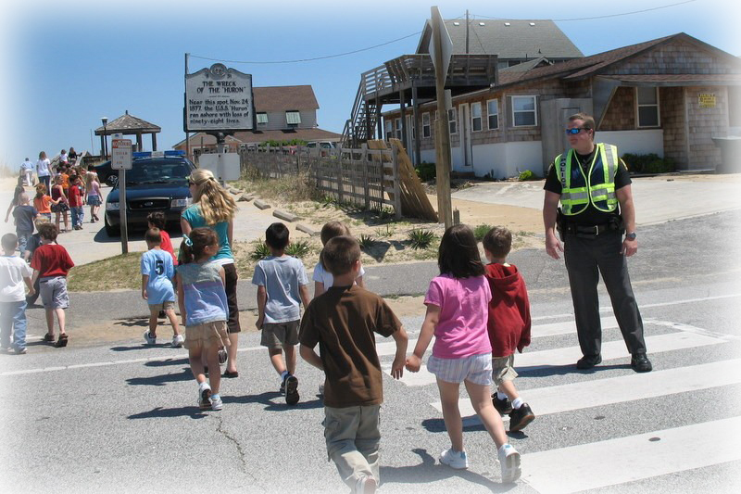
Department of Public Safety Overview
The Department of Public Safety is comprised of two divisions: The Police Division and the Fire and Rescue Division.

The Police Division strives to deliver high quality service to the residents and visitors of our Town. The prevention of crime is the highest operational priority; the Division places its highest value on the preservation of human life, the protection of property, and the provision of quality customer service to the public. The Police Division is divided into four operational units: Administration, Patrol, Criminal Investigation, and Animal Control. Effective July 1, 2009, the Administrative Unit consists of the police chief, deputy police chief, one police lieutenant’s position (currently frozen), one office/systems manager, and one office assistant. The Administrative Unit performs the administration, records keeping and computer operation of the Division.

The Patrol Unit is composed of four sergeants and all uniformed police officers. This unit delivers basic law enforcement service to Nags Head. The Criminal Investigation Unit is composed of one sergeant that oversees the unit, along with police officers specifically designated to investigating crimes occurring within the Town's corporate limits. The Animal Control Unit is composed of one police officer who is responsible for the operation of an effective animal control and protection program in the Town.

The Fire and Rescue Division is composed of two operational units: Fire and Rescue and the Ocean Rescue Unit.

Fire and Rescue responds to fire and general rescue calls and mutual aid requests from other jurisdictions. In addition, the unit performs fire code inspections and completes fire cause investigations. The Ocean Rescue Unit provides water rescue services from April through October. During the summer season, Nags Head beaches are protected and patrolled by lifeguards on all terrain vehicles (ATV’s) as well as lifeguards on lifeguard stands strategically positioned along the oceanfront.

Effective July 1, 2009, the Department of Public Safety was eliminated and the Police Division and Fire Rescue Division both became separate departments. This change, however, did not effect the 2008-2009 fiscal year on which this report is based.

Police Division
A review of Fiscal Year 2008 - 2009 found this to be a rewarding and successful year. The Police Division continued to provide quality service in a professional manner to all.

Calls for Service
During Fiscal Year 2008 - 2009, calls for service, dispatched through Dare Central Communication, saw Nags Head police officers responding to 10,568 calls. This reflects an increase of 26 calls from the 10,542 calls during Fiscal Year 2007 - 2008. Again this fiscal year, the Police Division provided approximately 400,000 miles patrolling and responding to calls for service in the Town.

Burglaries
Police officers responded to 132 burglary calls during Fiscal Year 2008 – 2009, compared to 142 calls in Fiscal Year 2007 – 2008. Nags Head police officers made 24 burglary arrests during 2008 – 2009, compared to 19 in 2007 - 2008. Burglaries to residential, absentee owner, and rental cottages remain as the area in which the town is, crime wise, most vulnerable, especially during the late fall and winter off-seasons.

Larcenies
Police officers responded to 142 calls occurring during Fiscal Year 2008 - 2009 compared to 152 calls during Fiscal Year 2007 - 2008. The police officers made 54 larceny arrests during Fiscal Year 2008 - 2009 compared to 39 made in Fiscal Year 2007 - 2008.

Domestic and Public Street Affrays
Police officers responded to 197 calls for service for public drunkenness and disturbances during Fiscal Year 2008 - 2009. There were 52 arrests for disturbances made during Fiscal Year 2008 - 2009. Disturbance type arrests are identified as resist/delay and obstructing a law enforcement officer, creating a disturbance, and affray (fighting in public).

Controlled Substance Calls
Controlled substance calls increased to 91 calls during Fiscal Year 2008 – 2009, compared to 71 calls during Fiscal Year 2007 - 2008. Police officers charged 228 controlled substance violations during Fiscal Year 2008 – 2009, compared to 198 during Fiscal Year 2007 - 2008. Statistics show that many of the drug charges were developed through the successful deployment of the Town’s K-9 Unit.

Alcohol Related Calls
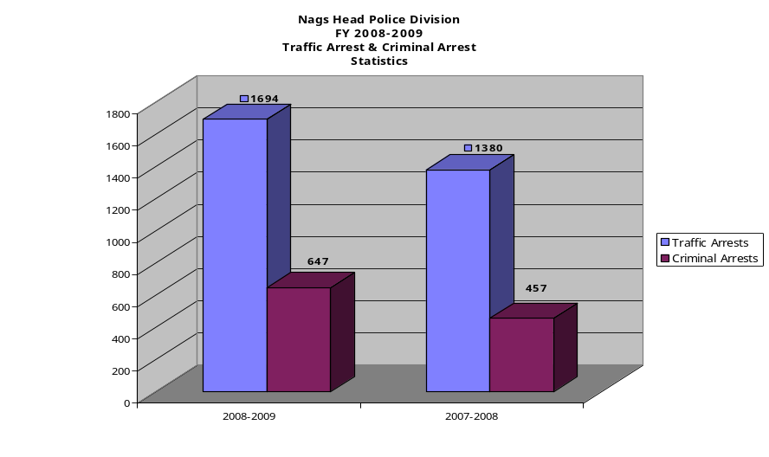
Police officers responded to 21 ABC Violation (Alcohol) calls during Fiscal Year 2008 - 2009. Police officers made a total of 236 alcohol related arrests for Fiscal Year 2008 - 2009. In Fiscal Year 2007 - 2008 police officers had 243 alcohol related violations.

Dispatched Alarm Calls
Dispatched alarm calls increased during Fiscal Year 2008 – 2009, with 554 calls being reported compared to 548 during Fiscal Year 2007 - 2008.

Criminal Arrests
The number of criminal arrests during Fiscal Year 2008 - 2009 was 647 compared to 565 criminal arrests made during Fiscal Year 2007 - 2008.

Traffic Related Enforcement Actions
The number of traffic related enforcement actions during Fiscal Year 2008 - 2009 was 1,694 compared to the 1,380 actions during Fiscal Year 2007 - 2008. There were 1,036 warnings issued this fiscal year compared to 1,551 warnings issued in Fiscal Year 2007-2008.

Community Activities
The Police Division is in the 16th year of its Community Policing Program. As in years past, citizens have come together to demonstrate their commitment towards community partnership by taking an active role in the Nags Head Community Watch Association. This partnership has become a valuable aid in helping to keep our communities safe.

The Town’s permanent residents continue to participate in Community Watch. Citizens and visitors reported 244 suspicious person(s), with another 194 reports of suspicious vehicle(s) reported during Fiscal Year 2008 - 2009.

The success and strength of this continuing community partnership was again demonstrated on August 5, 2008, when the Police Division, Community Watch Association and over 100 of our residents, absentee property owners, and visitors turned out in 19 of our 21 neighborhoods to participate in the 26th Annual National Night Out Against Crime. Several businesses and citizens again supported the Nags Head Community Watch Association and "National Night Out" by sponsoring block parties in some of our neighborhoods. This year, for the seventh year, the Police Division hosted the Community Watch Association, the neighborhood Community Watch Block Captains, and Community Watch members to a National Night Out picnic in Fire Station 16.

On December 10, 2008, the Community Watch Association hosted the Town of Nags Head’s Police and Fire Divisions at a luncheon to extend their thanks and appreciation to the police, fire, and ocean rescue staff and civilian police and fire personnel for their continuing efforts to help preserve the quality of life here.

During each month's Community Watch meeting, the general public is invited to come and listen to speakers from the local community who provided unique information on specific areas of interest. In an effort to increase attendance the Board of Directors of Community Watch elected to change the monthly meetings to every other month. During the March 2009 meeting, Police Officer Lora Gilreath provided information on the Town’s animal laws and regulations. During May’s meeting, Police Officer Trey Lipscomb and K-9 “Boss” demonstrated the effectiveness of our multi-purpose police K-9. In October, Fire Captain John Kenny gave a presentation on fire prevention.

The Police Division continued the successful use of the Polaroid "Ident-A-Kid", "Domestic Violence Prevention", and "National Child Passenger Safety Seat" programs during Fiscal Year 2008 - 2009. Each of these programs continues to be well received. In addition, the Police Division continues to inspect child safety seats on a regular basis.

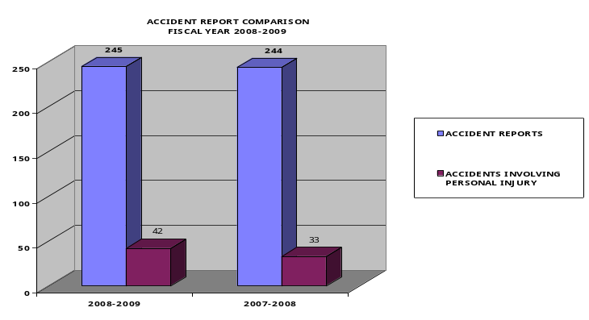
Throughout the year, Police Division personnel review and analyze crimes and crime causal conditions within the Town. This information and analysis was used to deploy personnel and resources to address identified crime, crime causal factors, and conditions.

Motor Vehicle Accidents and Traffic Safety
Nags Head experienced 245 motor vehicle accidents during Fiscal Year 2008 – 2009, an increase of 1 accident from Fiscal Year 2007 - 2008. Forty-two of the 245 accidents resulted in personal injury, compared to 33 personal injury vehicle accidents that occurred during Fiscal Year 2007 - 2008.

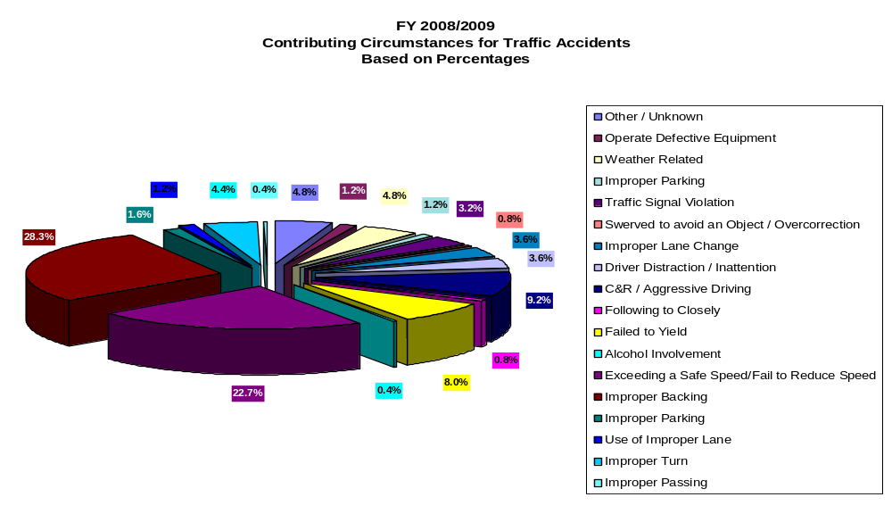Contributing factors in the motor vehicle accidents were: improper backing (28.4%), exceeding a safe speed (22.8%), alcohol involvement (.4%), failure to yield (8%), and following too closely (.8%). A majority of the motor vehicle accidents continued to be the direct result of driver negligence, failure to maintain a proper lookout while turning, changing lanes, pulling onto roadways from private businesses or side streets, or when pedestrians failed to maintain proper lookout while crossing roadways. Drivers running red lights contributed to some of the most serious personal injury motor vehicle accidents.

The Police Division continued to address the issues of traffic safety, awareness, and education by deploying the Town’s mobile radar display trailer throughout the residential neighborhoods.

The Police Division continues to meet with the North Carolina Department of Transportation to address traffic and pedestrian safety concerns. These meetings continue to be effective in finding ways to improve safety in dealing with the ever-increasing traffic in Nags Head.

Personal Watercraft
During Fiscal Year 2008 - 2009 the Nags Head Police Division responded to 4 calls for service involving personal watercrafts.

Special Events
The Police Division participated in a number of special events during Fiscal Year 2008 - 2009.

On Sunday, November 9, 2008, the 3rd Annual Outer Banks Marathon took place. All Police Division personnel worked this event. The Police Division took the lead in lessons learned from the previous year’s marathon. Changing the start location and pursuing a staggered start resulted in the Police Division seeing improved traffic/crowd control. The Department of Public Safety’s mobile command center was utilized to coordinate all communications during the event.

The Police Division provided traffic and crowd control during the 2009 St. Patrick's Day parade. This event is promoted as the largest of its kind in North Carolina and was very well attended. Police staff spent valuable time planning for this event to provide for the safety of each participant. Once again the parade was incident free. Police Division and Town staff met with the organizers to implement changes that will help provide a better and safer event in the future.

During the annual Outer Banks Bike Week held in April 2009, the Police Division provided support with both on-duty and off-duty personnel. This event was very well attended. The only incident during this year’s event involved a motorcycle accident. The driver of the motorcycle was found to be intoxicated and was charged with Driving While Impaired.

The July 4, 2008 fireworks spectacular was hosted by the Town and held at the Nags Head Fishing Pier. This event was again very well attended. Traffic and crowd management plans were executed as designed with no incidents or problems being reported.

The Town wishes to extend its appreciation to Andy and Lovie McCann, owners of the Nags Head Fishing Pier, for allowing the July 4th, 2008 fireworks spectacular to be held on their property. The fireworks display was again a huge success and helped to further enhance the Town's image and commitment to remaining the "Premier Family Beach" on the east coast. Many of the Town's Public Works, Police, and Fire employees contributed to the success of this year's fireworks display.

Bicycle Patrol Officer Program
The Police Bicycle Patrol program continues to play an important role during special events as well as during our community policing efforts. This program allows officers to patrol and respond to calls during special events, when it is impossible to respond by vehicle. Additionally, the program allows officers to come in contact one on one with the public while patrolling. The program continues to be well received. During Fiscal Year 2008 - 2009 the Police Division was able to certify 2 additional staff members as bike officers.

K-9 Unit
The Nags Head Police Division’s K-9 Unit is now in its 4th year. Our K-9 officer, Trey Lipscomb, trains with his partner Boss on a daily basis, fine tuning skills in the identification of controlled substances. Under Officer Lipscomb’s leadership, Boss has been instrumental in a number of drug investigations. Boss attended several community events this year and is very well received by people of all ages.

Police Training
Police personnel, both sworn and civilian, continued to receive training during Fiscal Year 2008 – 2009, which amounted to approximately 1,958 hours. Training was conducted in areas that range from community policing to career development training, and technical and professional training.

Our continued emphasis on training and career development has helped to make and maintain our Police Division as one of the best-trained, professional, and technically proficient law enforcement agencies in North Carolina.

On April 6, 2009, Nags Head’s Police Division announced that Sgt. Doug White had recently completed the Tactical Training Certificate program at the North Carolina Justice Academy. This certificate program recognizes the achievement of law enforcement professionals who have dedicated themselves to making their communities and neighborhoods safer for North Carolina’s citizens and visitors. Program participants must be sworn members of a law enforcement agency and have at least 2 years of full-time law enforcement experience. Sgt. White completed 500 hours of training within a 5 year period that included a variety of tactical oriented courses.

Since January 1, 2005, the North Carolina Criminal Justice Training and Standards Division has required an additional 24 hours of mandatory law enforcement training to be completed each calendar year for every certified law enforcement officer. This mandatory training accounts for 550 additional law enforcement officer training hours.

This additional training requirement is a continuing mandate for each officer and will be required to be completed each year. All North Carolina mandated in-service, firearms, and use of force training was completed as required by the State as of December 31, 2008.

The Nags Head Police Division continues to address training needs, as well as other important issues of concern to all of the other municipal law enforcement agencies and the Office of the Sheriff of Dare County. The Nags Head Police Division, Kitty Hawk Police Division, and the Dare County Sheriff's Office each hosted training classes during Fiscal Year 2008 - 2009. This regional approach to training continues to allow each participating agency to train more officers at one time, giving an opportunity for area law enforcement officers to train together, and saving police officer work days that would have been previously spent traveling back and forth to the Criminal Justice Academy campuses. This equates to more time patrolling the streets and neighborhoods. The area law enforcement agencies look forward to hosting an even greater number of training schools and seminars during the coming years.

Animal Control
Officer Gilreath continued to proactively work with residents and visitors in ensuring compliance with animal control rules and regulations.

On February 28, 2009, officers with the Nags Head Police Division, along with officers of the Dare County SPCA, conducted a rabies clinic at Town Hall. During this event, the Dare County SPCA administered over 60 rabies shots. Nags Head police officers fingerprinted children as part of the Ident-A-Kid program in addition to inspecting child safety seats to ensure compliance with NC General Statutes. The Nags Head Police Division Community Watch organization helped sponsor this event and members were on hand to recruit new participants to the organization.
During Fiscal Year 2008 - 2009, the number of animal control calls was 619, compared to 589 in Fiscal Year 2007 - 2008. Sixty-eight animals were taken into custody, transported to, and turned over to the Dare County Animal Shelter during Fiscal Year 2008 - 2009. In addition, 35 animal related citations, Town tickets, and warning tickets were issued during Fiscal Year 2008 - 2009. Wildlife was also relocated to safer settings on 4 occasions, and 40 animal traps were provided.

There were 13 animal bite incidents reported during Fiscal Year 2008 - 2009, with the animals being quarantined for a total of 10 days. The animal control officer participated in Rabies educational efforts to increase the public knowledge of this most serious public health threat.

Career Development
All eligible Police Division employees, both sworn and civilian successfully completed the requirements of the Town's Career Development program during Fiscal Year 2008 - 2009.

Chaplain Program
The Public Safety Department’s Chaplain Program was again very beneficial during Fiscal Year 2008 - 2009. Pastor Rick Lawrenson from the Outer Banks Church and Pastor Jim Lewis from the Ark International Church served as our Public Safety chaplains. Both chaplains regularly participate in the Town’s Memorial Day and Veterans Day ceremonies, as well Community Watch Association events.

Chaplains Lawrenson and Lewis are familiar faces around town, volunteering their time in the Police and Fire Divisions. Both Public Safety chaplains are a welcome and valuable asset.

Special Meetings within the Community
During Fiscal Year 2008 - 2009, Nags Head Police Division representatives attended several North Ridge Homeowner Association meetings to address concerns within the neighborhood. Nags Head police officers also conducted security surveys at local businesses and presented crime prevention techniques to local merchants.

Police Grant Initiatives
During Fiscal Year 2008 – 2009, the Nags Head Police Division applied for funding from the Governor’s Crime Prevention Commission for a virtual private network. The Nags Head Police Division was the host agency for this regional grant called “Netmotion Mobility XE”.

In July 2009 the Town was notified that it would receive over $10,000 in funding. This project, once fully implemented, will correct an unsatisfactory level of service for our officers who use wireless broadband cards to connect their in-car computers to Dare County’s digital dispatch system and the Division of Criminal Information (DCI).

Nags Head Police Division Office Manager/IT Specialist Lisa Ward worked countless hours during the application process for the grant. It is due to her hard work that the Town of Nags Head’s Police Division, as well as the other five municipalities, will be able to have this type of equipment/service at a minimal cost to our tax payers.

High Profile Investigations
  - On June 30, 2008, at approximately 1 a.m., uniformed officers with the Nags Head Police Division stopped a 2008 Dodge Charger vehicle being driven by Bridgette Denise Charity, a 21 year old female from Greenville, NC for a traffic violation. Also in the car was Stephanie Louise Royal, a 23 year old female from Greenville, NC. A search of the vehicle resulted in the seizure of approximately 1.5 pounds of marijuana along with $3,900. Both women were arrested and transported to the Dare County Detention Center. Charity was charged with possession with intent to sell/deliver marijuana, possession of drug paraphernalia, and driving while license revoked. She is currently incarcerated with a $27,000 bond. Royal was charged with possession with the intent to sell/deliver marijuana and possession of drug paraphernalia. An outstanding felony warrant from Tarboro, NC was also served. Royal is incarcerated with a $51,000 bond. Additional charges are pending against both subjects.
  - On July 18, 2008 at approximately 9 p.m., three males were arrested for narcotics violations. Officers were in the 2400 Block of Croatan Hwy. on routine patrol when they came in contact with the three males. After recovering approximately 24 grams of cocaine, the subjects were arrested and transported to the Dare County Detention Center. Rolando Martinez Rubio, 27, from Nags Head, was charged with possession with intent to sell/deliver cocaine and was given a $5,000 bond. Martin Gonzales Romero, 31, from Elizabeth City, was charged with possession with intent to sell/deliver cocaine and given a $10,000 bond. Juan Gallegos, 27, from Elizabeth City, was also charged with possession with intent to sell/deliver cocaine and given a $10,000 bond. Additional charges are pending against each subject.
  - On July 19, 2008 at approximately 2 p.m., the Nags Head Police Division stopped a 1998 Buick Regal operated by Valenzuena Guillermo, a 36 year old male from Manns Harbor. Also in the vehicle was Marco Antonio Terrazas, a 25 year old male also from Manns Harbor. During a search of the vehicle approximately 29 grams of cocaine was recovered and each of the subjects was arrested. Guillermo was charged with 2 counts of trafficking in cocaine and Terrazas was charged with 1 count of trafficking in cocaine. Each subject was incarcerated in the Dare County Detention Center with a $75,000 bond.
  - On August 11, 2008 several vehicles were reported to have been broken into in the Old Nags Head Cove subdivision and in the Village at Nags Head. Four unlocked vehicles were entered on Blue Marlin and Pamlico Ways in Nags Head Cove. Money was removed from one of the vehicles, while others had nothing stolen from them. Four unlocked vehicles were also entered in the Village at Nags Head near the golf clubhouse. Money was the only item removed from these vehicles.
  - Also reported in the Old Nags Head Cove subdivision during this time was a larceny of a motor vehicle. A 1995 Ford Explorer was stolen from a residence on Pamlico Way. The vehicle was later recovered in Manteo.
  - On Monday, March 16, 2009 at approximately 5:20 p.m., a motor vehicle collision occurred at the intersection of U.S. Highway 158 (South Croatan Highway) and Danube Street in Nags Head. Thomas Reid Smith DeBlieu, 16, Manteo, died as a result of his injuries. DeBlieu was the sole occupant of a 2002 Ford driven by Taylor Catherine Carawan, 17, of Wanchese. The 2002 Ford was attempting to turn west onto Danube Street from S. Croatan Highway when it was struck broadside by a 1999 Jeep operated by Joseph Maurice Powell, 44, of Nags Head, which was traveling south on the highway.

Personnel
On May 15, 2009, the Town of Nags Head tragically suffered the loss of Sgt. Dulan Earl Murray, Jr., in a traffic accident while responding to a call of a residential burglary in progress. The accident occurred during a rainstorm on U.S. 158 near Villa Dunes Dr., when his vehicle lost control and struck a large utility pole on the passenger side, which resulted in Sgt. Murray’s death. The loss of Sgt. Murray was profound and shook the Public Safety Department to its core.

During the days following Sgt. Murray’s death, employees with the Town of Nags Head embraced the members of the Public Safety Department that worked so closely with Sgt. Murray. Employees from the various departments within the Town assisted in collecting and preparing food for the family and friends of Sgt. Murray. It was during this tragic time that the “Nags Head Family” was able to come together to help one another. The actions provided by Town employees were witnessed by family members, friends, and the entire law enforcement community that had come from many states to pay tribute to him.

On May 15, 2009, Town Manager/Public Safety Director Charles Cameron retired, after serving the Town for over 14 years.

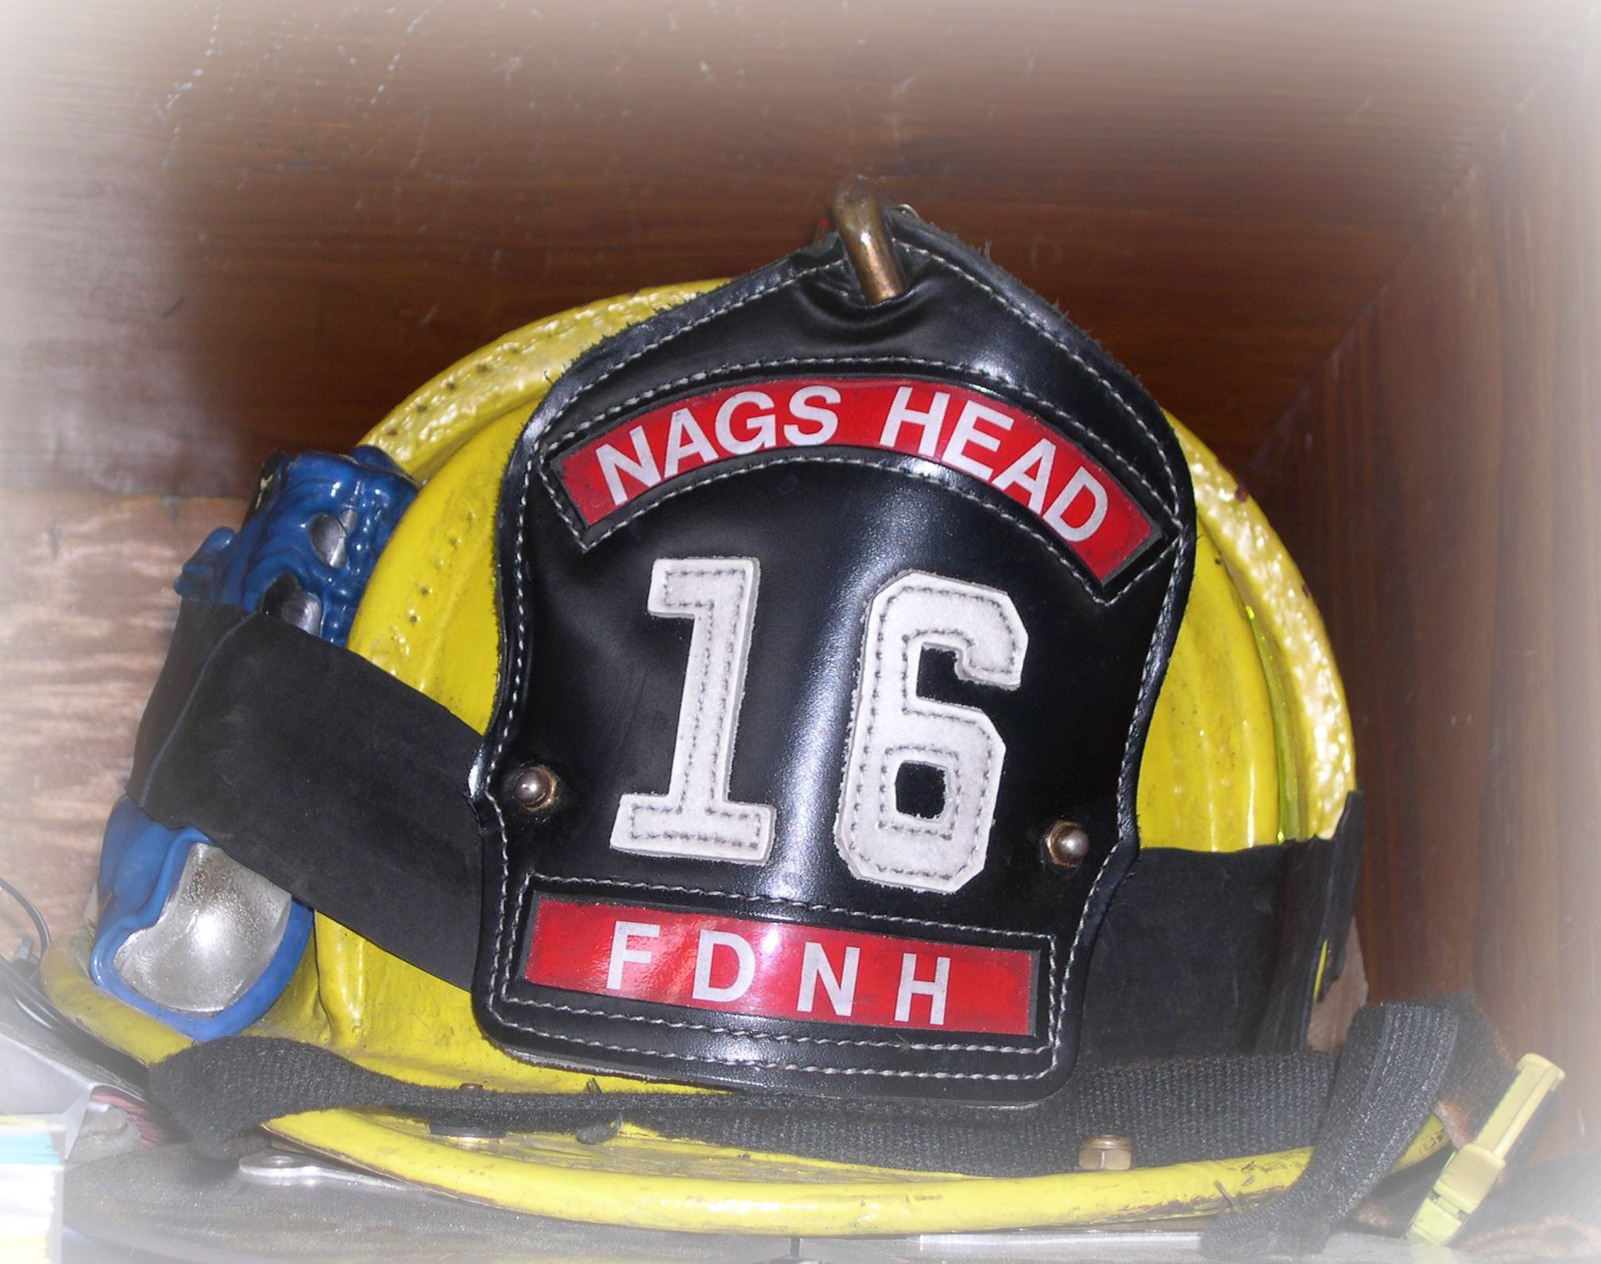
Fire and Rescue Division

Fire and Medical Response
Total emergency response by Nags Head Fire and Rescue increased to 852 emergency calls in Fiscal Year 2008 - 2009 from to 759 in Fiscal Year 2007 - 2008. Nags Head Fire and Rescue responses to emergency medical calls decreased by 14 calls for the year, for a total of 344.

The Fire and Rescue Division experienced increase in responses involving Nags Head commercial properties in Fiscal Year 2008 - 2009. A total of 262 emergency responses to these commercial properties were logged in Fiscal Year 2008 - 2009, as compared to 241 responses in Fiscal Year 2007 - 2008. Residential emergency incidents increased by 7 calls for a total of 317 incidents. The remaining incidents were open land, beaches, and highways. The overall structural fire dollar loss for Fiscal Year 2008 - 2009 was $12,900 as compared to a structural fire loss of $4,830 in Fiscal Year 2007 - 2008.

There were no significant fire events (estimated loss of $10,000 or greater) that occurred in the town during Fiscal Year 2008 - 2009.

Fire Inspections
The Nags Head Fire inspections program is the core of damage and injury prevention in Nags Head and provides ongoing fire defense in commercial facilities.

There were 349 fire inspections of Nags Head commercial properties completed this year. Inspections included assembly, business, institutional, multi-family residential facilities, and certificate of occupancy evaluations. Additionally, fire staff participated in numerous technical reviews of commercial site plans and crowd gathering permits.

A highlight of the fire inspection program this year included additional staff becoming certified as Level I, II, and III Fire Prevention Inspectors. This education provides increased depth and knowledge to the fire prevention program, certifying that on-duty inspectors are able to conduct hazard recognition activities with accuracy. The goal of the Fire Division is to have every firefighter become a Level I inspector and supervisory staff achieve higher service levels as a Level II or III inspector. The development of advanced inspector certification levels this year allowed for sharing of progressively difficult tasks such as technical site plan review and evaluation of property redevelopment. The State of NC Fire Inspector continuing education program, requiring 6 hours of annual code based training, was completed for all fire inspectors in June 2009. Additionally, Nags Head Fire and Rescue collaborated with the College of the Albemarle to present Fire Inspector I and Law and Administration classes. Two additional inspectors realized level I certification because of these efforts. Town of Nags Head Fire Inspectors continues to grow in the prevention field, solving more complex and interactive fire code matters. On-site mitigation efforts helped reduce the chances of uncontrolled fire in commercial occupancies. This intervention, in turn, limited occupant safety impacts and improved the overall quality of life for Nags Head residents and visitors.

Fire Prevention and Mitigation
Nags Head Fire Rescue staff are committed to the vision of fire safety for the citizens and visitors in Nags Head. Fire staff and equipment were present with fire safety literature, youth fire helmets, stickers, and fire apparatus at the following public events; Annual Nags Head Fire Rescue Fire Prevention Night, Outer Banks Hospital Birthday Baby Day, OBX Homebuilders Expo, Nags Head Police Annual Easter Egg Hunt, Nags Head Police National Night Out, and the St Patrick’s Day Parade.

Nags Head Fire staff assisted the area Fire Divisions with “Fire Prevention Week” activities at First Flight and Kitty Hawk Elementary schools, and scheduled visits to Nags Head Elementary and pre-schools. Nags Head residents and numerous vacationing visitors continue to stop by Station 16 and Station 21 to visit the firefighters, take pictures of apparatus, or tour the facilities. Nags Head Fire Rescue staff submitted various fire prevention articles to the local newspapers, Town Of Nags Head “Lines” Newsletter, and spoke to vacationing groups regarding fire safety while on vacation. The Government Access Channel continues to display the “Fire Safe” power point. Group e mail advisories are distributed to those interested in seasonal fire prevention topics. The Nags Head Fire website, updated monthly, is full of timely fire and consumer safety product information, informing a curious public how they can best prevent injury or loss of life.

National Fire Prevention Week activities in October offered community members an opportunity to tour Fire Station 16, meet firefighters, participate in fire extinguisher training, learn about residential fire inspections, and receive free smoke detectors. Participants also conducted “EDITH, Escape Drills in the Home” in the Dare Fire Safety Trailer. Approximately 300 people attended this important event that established Nags Head Fire Rescue as a fall gathering point for community fire education.

Fire Training
Career fire staff attended numerous in-house and off-site training classes for an aggregate of 3,765 hours. They also received classes in Ocean Rescue and technical rescues such as vehicle extrication and confined space. The Fire Marshal and three Fire Captains attended two week training classes at the National Fire Academy in Maryland. These classes focused on Fire Prevention and Leadership in the Fire Service.

Ocean Rescue
During Fiscal Year 2008-2009 the Ocean Rescue Unit updated two significant areas of equipment, to include: two – Honda ATV Ranchers, and one Ford F150 pick-up truck. The replacement ATV’s and pick-up truck have provided for more timely and efficient response and rescue operations.

In July 2008, twelve Ocean Rescue personnel traveled to Carolina Beach, SC to compete in the United States Lifesaving Association – South Atlantic Regional Lifeguard Championship. Nags Head took first place in the “B” Division (a staff of less than 50 guards). Later in July of 2008, five female members traveled to Sandy Hook, NJ to compete in the 24th National Park Service All-Women Lifeguard Competition. In August, two Ocean Rescue personnel traveled to Los Angeles, CA to participate in the USLA National Championships, placing tenth overall, including a first place finish by Captain Chad Motz in the 2km beach run.

The beaches were closed for 15 days this fiscal year, due to several Northeasters and tropical storms.

The following comparative statistics pertain to the activity of the Ocean Rescue Unit for the 2008 - 2009 and 2007 - 2008 fiscal years.

 |  | FY 2008-2009 | FY 2007-2008
Water Rescue |  | 100 | 104
People Assist |  | 133 | 162
Watercraft Assist |  | 5 | 8
Lost person Search |  | 13 | 27
EMS Assistance |  | 33 | 34
Near Drowning |  | 6 | 1
Drowning |  | 0 | 0
Deaths on Beach |  | 0 | 4
Animal Calls | Dogs | 228 | 109
 | Marine Animals | 7 | 117
Education Advisories |  | 91,227 | 90,159
Beach Closings |  | 15 | 11
Emergency Response –  No Assistance Needed |  | 2 | 6
Mutual Aid Response |  | 0 | 1
Beach Population |  | 659,286 | 721,144

Nags Head Reserve Firefighters
The participation of reserve staff contributed to the success of fire operations. Fire Station 16 totaled 1,322 of standby hours in Fiscal Year 2008 - 2009, compared to 1,350 in 2007 - 2008. Reserve firefighter training hours this year totaled 723.

Nags Head Reserve firefighters continue to provide services in Nags Head; however, nationally, regionally, and locally volunteerism has decreased. The Nags Head Reserve core group has served the Division well, but committed new members are a rare commodity and members active in the past have slowly faded from Division activities.

There is a re-energized recruitment effort ongoing to try and attract more participation within the Reserve program.

Infant Car Installation Program
The Fire Division maintains an excellent Child Seat Safety Program. Firefighters install and/or adjust child seats, as well as provide education to parents on a daily basis. The Fire Division has also become involved in a statewide program. We are now the secondary county coordinator for the North Carolina Child Safety Seat Coalition. This includes providing quarterly reports to the state, as well as reporting the number of seats that have been checked. The Fire Division has been able to provide approximately 20 child seats to families who could otherwise not purchase them on their own. During Fire Prevention Night and Child Prevention Safety Week, firefighter infant car seat technicians set up a car seat checkpoint so those transporting infants could determine if car seats were properly installed. Numerous deficiencies were found. The infant car seat inspection program is growing and visitors often stop at Stations 16 and 21 to request a car seat installation. There were 126 car seats inspected this year, which is above last year’s total of 78. Of these, numerous corrections were made and parents were educated on proper installation techniques. The Town of Nags Head looks forward to future participation in this initiative focused on infant injury prevention. The Fire Division also sponsored a Technician Certification class this year. At the end of the week, technicians provided child seat checks to numerous seats at a clinic that was held at a local daycare center. This provided a great opportunity for meeting with parents and assisting with their needs. The Fire Division currently has 20 technicians on staff, which has enabled us to provide an excellent service to the community, and has become a well respected program.

Nags Head Safety Program
The desired outcome of the Nags Head Safety Program is to eliminate employee injuries and mitigate hazards in Town facilities. The Town is dedicated to employee occupational safety and the maintenance of a healthful workplace. All accomplishments this year could not have been completed without a total management/employee commitment, communication, and a priority of "Safety First" in the workplace.

Lost workdays for all Nags Head personnel this year totaled seventy; these losses were attributed to 11 recordable injuries. The most frequent “damage to equipment” incidents occurred while employees were operating motor vehicles, identifying the need for ongoing driver training and situational awareness programs. Collectively, employee injuries decreased by 3 this year over the last evaluation period. Sadly, the Town of Nags Head family of employees experienced a first time ever loss; an employee involved in a single vehicle crash lost his life during the event.

The Safety Committee met monthly to discuss occupational matters, review incidents, and recommend new equipment or processes. Town staff participated in various safety events and training opportunities this year: Annual Safety Congress, CPR for Employees, Audiometric Testing, Wellness Facility upgrades, and inspections and personal protective equipment distribution for all affected employees. Facility improvements included HVAC upgrades for Station 16, and a new fire alarm panel for the UNC Coastal Studies facility.

Safety Program highlights includes presentation of the North Carolina Department of Labor Gold & Silver Safety Awards for various Town departments, a May 7 Safety Luncheon for employees, and a 2009 Safety Week Proclamation declared by the Nags Head Board of Commissioners.


Public Works
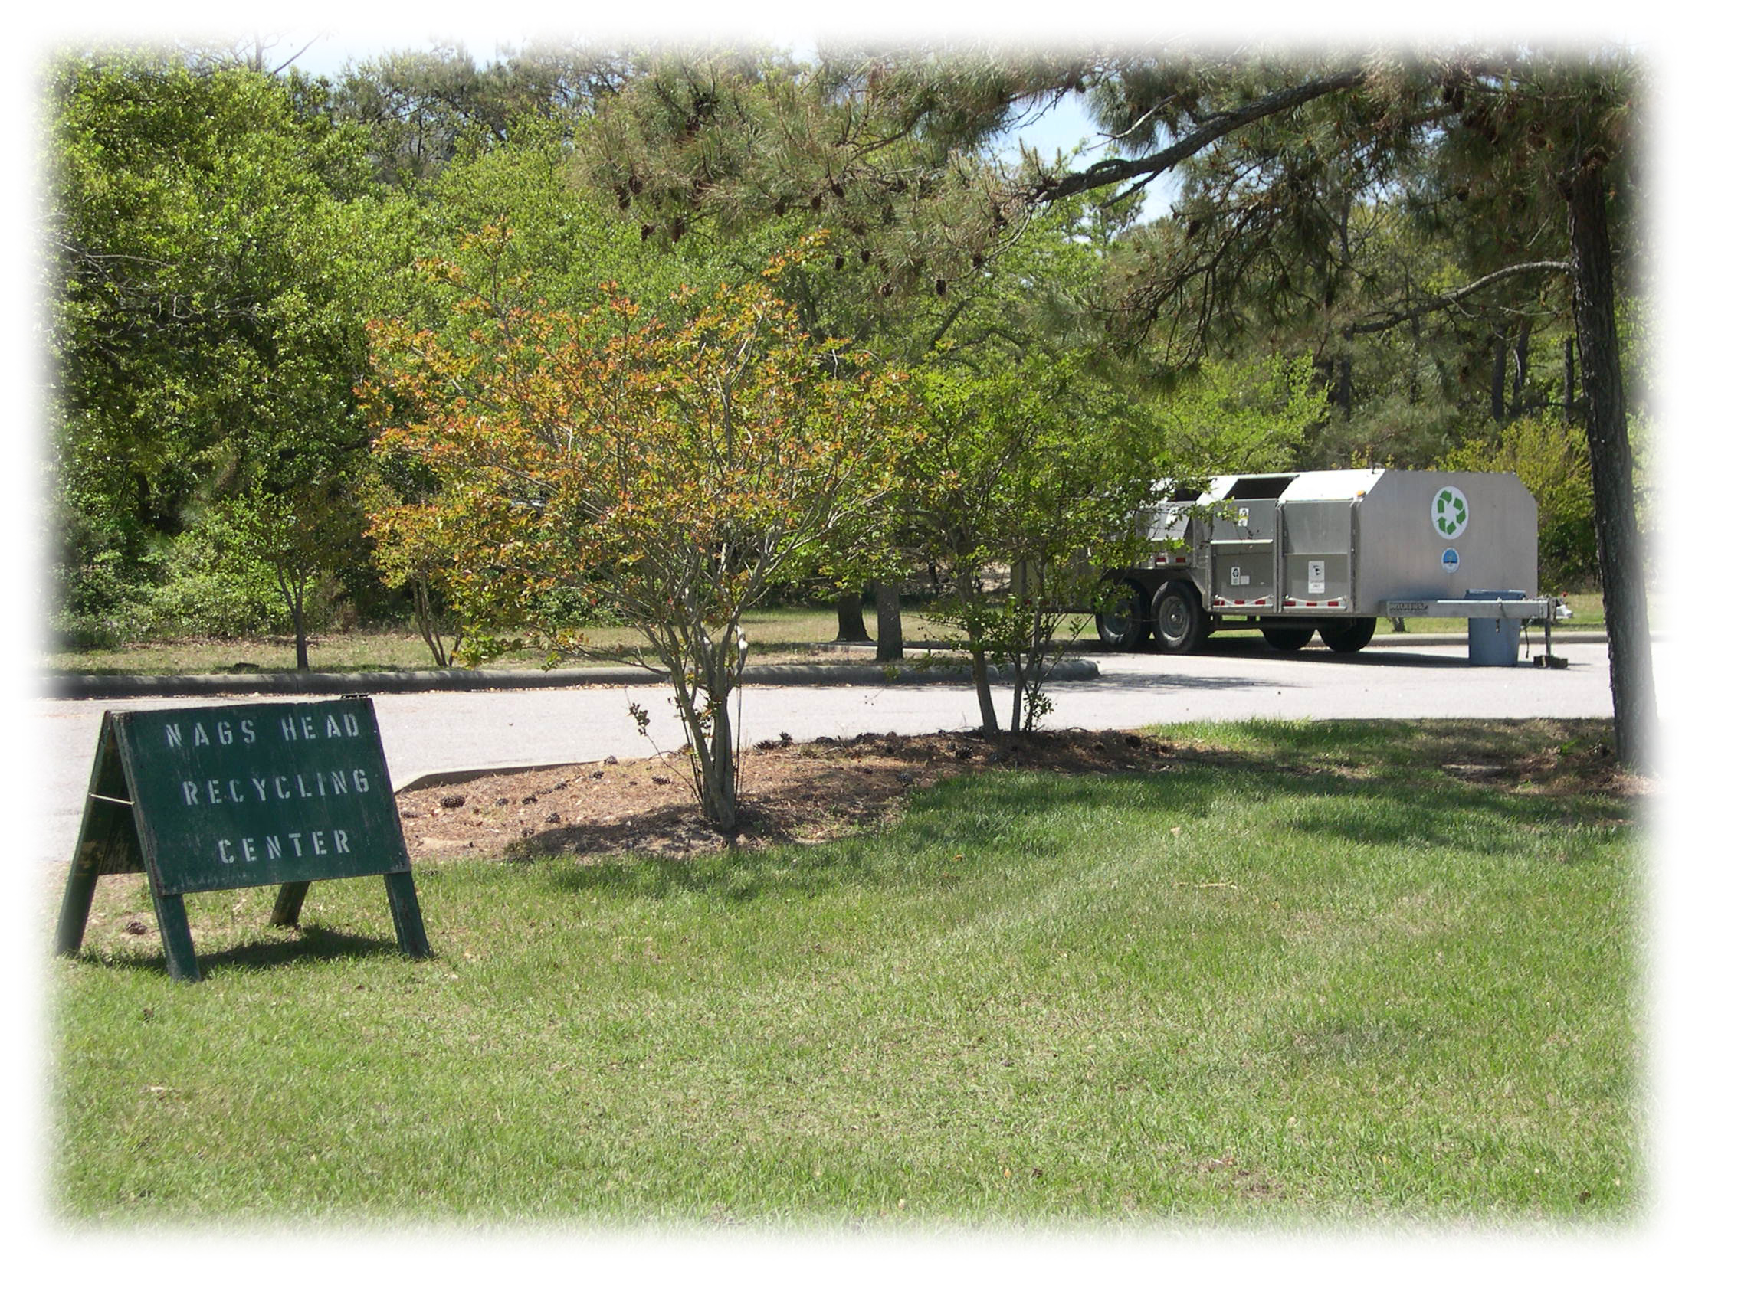
The Public Works Department is comprised of an Administrative section and five divisions: Fleet Maintenance, Public Facilities Maintenance, Sanitation, Water Distribution, and Water Operations.

Public Works Administration
Public Works Administration had an extremely busy year with routine activities and several major construction/renovation projects. Public Works provides project bidding and contract development and administration.

Major completed projects include:

- Fresh Pond Water Treatment Plant Shutdown
This work included removal and capping/plugging of the line connecting Fresh Pond to the Dare County Regional Water System, and removal of a portion of the backwash water conveyance system, adjacent to the filter building.
- Eighth Street Water Plant Motor Control Center Removal
The Eighth Street Water Plant motor control center, which controls the pumps providing water to the northern portion of town, was completely removed and replaced. This work was done during the late winter and did not adversely impact water supply to any portion of the town.
- Baltic Street Public Beach Access Construction
The construction of a new handicapped accessible public beach access at Baltic Street was completed during this fiscal year. The access features a wheelchair accessible ramp, 17 parking spaces – 15 utilizing permeable pavers, shower, bike rack, bench, landscaping and sign. Another component of this project involved the installation of 6 additional parking spaces on the south side of Baltic Street, to the west of S. Virginia Dare Trail. This work was completed with Powell Bill funds.
- Street Repaving
Using Powell Bill funds, the Town repaved S. Hammerhead Drive, Blue Jay Street from the US 158 to Pamlico Avenue, and Wrightsville Avenue from Eighth Street to Albatross Street. The portion of Forbes St. between US 158 and S. Virginia Dare Trail was also completed and included the installation of a culvert and catch basin.
- West-Side Multi-Use Path – Phase II Construction
The second section of the west side multi-use path was completed in Fiscal Year 2008 – 2009. Constructed on the west side of US 158, from Carolinian Circle to Oak Knoll Drive, this 401 foot long, 10-foot wide concrete path will eventually be extended further south towards the entrance to Jockey’s Ridge State Park. The next (2,800 foot) section, from Oak Knoll Drive to Barnes Street, is being designed and will be bid and is planned for construction in Fiscal Year 2009-10.
- Stormwater Projects
Public Works Administration provided project oversight and coordination for stormwater projects along the Finch and Grouse Street rights-of-way.
- Sand fencing Installation
Public Works Administration completed the installation of an additional 7,000 feet of sand fencing along the oceanfront.
- Fire Station Mold Remediation
Public Works Administration completed a major mold remediation and HVAC rehabilitation project at Fire Station 16.

In addition to the projects listed above, Public Works Administration assisted the various divisions of Public Works with developing specifications and purchasing several replacement vehicles and pieces of equipment. Included were three replacement pickup trucks for various divisions, and one new residential refuse collection truck.

Public Works Administration was again involved in planning the July 4th fireworks display on Nags Head Fishing Pier, assisting Public Safety. This event was another rousing success.

We continue to emphasize training for our employees. During the year Office Assistant Barbara Minter attended training in “Managing & Supervising People” and “Administrative Assistants Conference” and “Grammar & Proofreading”. In addition, Karen Costello, Public works office manager, completed a course entitled “Business Writing & Grammar Skills”.

During Fiscal Year 2008-2009, we processed 7 warning letters for Sanitation Code violations. We try a phone call to the customer to solve the problem first, but if this is not productive, a warning citation is then sent out. We issued no Civil Citations.

Calls were received and processed for special collections as follows:

Cardboard Collection: 2 calls | Cart Repair: 212 calls
Bulk Collection: 654 calls | Cracked Carts: 87 calls
Christmas Tree Collection: 57 calls | Mulch Delivery: 32 calls
Cart Rollback: 32 calls | Dumpster Repair: 13 calls
White Goods: 234 calls | Cart Delivery: 39 calls
Brush & Limb Collection: 1,025 calls | Dumpster Delivery: 19 calls
Bagged Yard Waste Collection: 92 calls | Special Requests: 1 calls

Fleet Maintenance
Fleet Maintenance performs scheduled equipment and vehicle preventive maintenance procedures (which include maintaining sufficient inventory), vehicle repairs, call-out emergency repairs, and various modifications to meet other departmental needs. The department’s major emphasis and goal is preventive maintenance. However, the number of unexpected breakdowns affects the day-to-day operations of the department. There is no way these can be predicted and factored into daily or weekly work schedules. It is the goal of this department to achieve its maximum performance in order to help keep other Town departments operational.

The garage staff maintains an inventory of $29,882, along with diesel fuel and unleaded fuel for the Nags Head fleet. Fleet Maintenance is fully staffed with Fleet Superintendent Charlie Bliven, Senior Fleet Mechanic Patrick Norcross, and Fleet Mechanics David Fronius and Ron Watson.

There were 743 work orders for 2008-2009 and 2,236.1 labor hours. All 4 employees in the garage are certified North Carolina Vehicle State Inspectors. The staff is certified in various areas of automotive, medium - heavy truck and busses through Automotive Service Excellence, ASE.

New vehicles and equipment that was prepared, modified, and made ready for service in 2008-2009 by the staff include:

Public Works Administration Pickup Truck | Ocean Rescue Honda 4-Wheeler
Facilities Maintenance Pickup Truck | Ocean Rescue Honda 4-Wheeler
Planning Pickup Truck | Ocean Rescue Pickup Truck
Sanitation Dump Truck

In 2008-2009, several vehicles were sold on GOVDEALS.com and the staff was kept busy with decommissioning the items to be sold, getting the information organized, answering questions about what was being sold, and assisting in the items being picked up.

Training remains a key ingredient with staying current on new vehicles and equipment. The garage, along with Tidewater Fleet Supply, sponsored an Air Brake Clinic held at Fire Station 16 for area truck and trailer technicians to learn more in about air brake operation.

David Fronius led the Sanitation Truck #988 refurbishing project, which brought this vehicle back to where it could be used everyday as a frontline residential truck, in lieu of purchasing a new vehicle in the 2008-2009 fiscal year.

The garage staff continues to stay current with scheduled preventive maintenance, technology, and training to do their best for the Town of Nags Head.

Public Facilities Maintenance
Public Facilities Maintenance began maintaining the new multi-use path, along with maintaining the highway beautification beds along US 158 at the north end of town and in the vicinity of Town Hall. Several beach accesses also had to be repaired before the season. Facilities Maintenance completed all access repairs at the beginning of the year, with very little outside help. The division also assisted with stormwater projects.

Other large projects include:

- Facilities Maintenance, working in conjunction with other Public Works divisions and the Public Safety Department, was involved in the July 4th fireworks display on the Nags Head Fishing Pier.
- The third annual Outer Banks Marathon preparations, set-up, and tear down were completed this year along with mulching of the path from Town Park to Nags Head Woods Road.
- Facilities Maintenance was involved in mold removal and HVAC unit repairs at Fire Station 16.

Routine work continued to be heavy throughout the year. Facilities Maintenance oversees all Town facilities such as buildings, landscaping, streets, signs, drainage, the Town Park, beach accesses, crosswalks, and emptying of the trash cans on the beach. They service 130 trash cans and 6 public restrooms daily from May 1st through October 1st. In addition, Facilities Maintenance oversees the 11 miles of multi-use path along the beach road the entire length of town. They also oversee 36 miles of streets and a mile of sidewalk. In addition, Public Facilities Maintenance began maintaining the Windmill Point properties.

Town buildings were provided with painting, electrical, and plumbing repairs. Facilities Maintenance also oversees all of the janitorial needs for the Town’s Municipal Complex, the Board of Commissioners Meeting Room, and the Public Works building.

Facilities Maintenance has maintained all facilities to fulfill the requirements set forth by the Town to maintain the SHARP Award.

Hours spent on specific work include:

Building Maintenance: 1,341.0 hours | Landscaping Town Facilities: 1,470.5 hours
Beach Access Cleaning: 2,050.5 hours | Right-of-Way Mowing: 666.5 hours
Beach Access Repairs: 1,540.0 | Multi Use Path Maintenance: 1,784.5 hours
Cleaning Town Facilities: 2,277.5 hours | Miscellaneous: 1,112.5 hours
Street Maintenance: 621 hours | Installation of Regulation Signs: 228.5 hours
Drainage: 255 hours | Work in Other Depts: 87.5 hours

Sanitation
The Sanitation Division had another busy year with routine work heavy as usual.

The recycling program remained active with the following tonnages for main items collected at collection and commercial sites in Fiscal Year 2008-2009.

White Goods – 96 tons | Plastic #1 -7 tons
Aluminum – 17 tons | Plastic #2 – 5 tons
Brown Glass – 73 tons | Cardboard From All Other Sources – 300 tons
Clear Glass – 45 tons | Mixed Paper – 122 tons
Green Glass – 23 tons | Electronics – 1 ton

The grand total recycled for Fiscal Year 2008-2009 was 689 tons, a 24.41% increase from Fiscal Year 2007-2008’s total of 553.82 tons. A total of 815.72 tons of bulk pickup items were collected during Fiscal Year 2007-2008, an increase of 64% or 317.86 tons over last year.

There were a total of 32 loads of mulch delivered back to Town of Nags Head residents this year out of 804 cubic yards mulched. The remaining volume of the mulch was used on the paths in Nags Head Woods and road side beautification beds

The largest amount of material collected and transported by Sanitation was residential and commercial refuse. The residential total was 3,959.77 tons and commercial 4,608.02 tons, for a grand total of 8,567.79 tons. The total refuse declined 544.48 tons or a 5.98 % decrease from Fiscal Year 2007-2008.

In September 2008 the days of operation for the Brush Yard were changed from Tuesday, Thursday, and Saturday to Monday, Thursday, and Saturday. The loads for Fiscal Year 2008-2009 were: Monday’s 1,521; Tuesday’s 546; Thursday’s 2,425; and Saturday’s 2,571.

Sanitation collects electronics at the brush yard for recycling.

Water Distribution
Once again, with the continued decline in new water service installations, Water Distribution committed the majority of its efforts to infrastructure and meter route maintenance. With drought restrictions lifted, the entire water distribution system was able to be properly flushed this winter.

Distribution personnel replaced 87 water meters (3/4” to 2”) that had excessive usage, with new, more accurate meters and backflow protection. Three automatic flushers were installed in the low flow areas of south Nags Head, the National Park Service, and Pond Island, to assist in turning the water over in these areas. Water Distribution has also embarked on an extensive fire hydrant rehab project. This was an idea submitted from Water Distribution Technician/Operator Shane Baum to better service fire hydrants and save money by not having to purchase rehab kits. This process has the fire hydrants in the system, broken down in the field, brought back to the shop, completely stripped down to bare metal, inspected, primed and painted, then put back into the system looking and operating as a new hydrant. There have been 9 fire hydrants rehabilitated and placed back into service as of June 30, 2009.

With the two early season nor’easters, the distribution system suffered failures again on the oceanfront of Surfside Drive and Spencer Street. The system eventually lost the remainder of the 6” and 2” water mains on Surfside and a portion of 4” off of Spencer Street. Once again, neighbors had to work together to give the Town easements to restore water service to structures that were left without.

After several lengthy leak detection sessions followed by repairs, the water main extension from Villa Dunes Drive to the North Ridge subdivision passed all required pressure tests and was accepted and placed into service. This added 3,500’ of 8” water main to the system and added a 2nd source of flow and increased fire flows to the residents of Villa Dunes Drive. This, along with the Sugar Creek Condo project, added an additional 11 fire hydrants to the water distribution system.

This year, distribution technicians performed 11 water main repairs (2” through 12”), with 7 in relation to the early nor’easters. Technicians also completed 32 service line repairs (3/4” through 2”) and responded to 31 after hour call outs.

All Water Distribution Operators received the required contact hours to keep their existing mandatory state certifications active.

The Water Distribution Division installed the following number of water taps during Fiscal Year 2008-2009:
¾” – 9 | 1” – 6 | 1 ½” – 0 | 2” – 0

This compares to the following taps installed in Fiscal Year 2007-2008:

¾” – 16 | 1” – 18 | 1 ½” – 3 | 2” – 0

The number of locate requests were down this year to 911 compared to 1,103 in 2007-2008.

Water Operations
The Water Operations Division is responsible for supplying potable water to the citizens of Nags Head, as well as supplying treated water to the Dare County Regional Water System at a wholesale rate during the peak water demand period of the busy summer season from Fresh Pond. Fresh Pond operated from July 1, 2008 through August 16, 2008, and was permanently shut down June 3, 2009. (In October 2008, Dare County declared they no longer needed the Town to produce water from Fresh Pond. The contract between the County and the Town was amended, and the Town was released from our 1.5 million gallon/day obligation. In January 2009, Dare County put their new anion resin on line at their Skyco Water Treatment Plant. This resin helps reduce the trihalomethane (THM) formation potential of the Skyco water in the system once it leaves the plant. On June 3, 2009, the Nags Head Board of Commissioners voted to cease operating the Fresh Pond Plant.)

Water Operations is headquartered at the original Nags Head Water Treatment Plant located at 2210 Pond Avenue. Water Operations also maintains a pump station located at 104 Gull Street, two elevated water tanks, and serves Nags Head citizens by providing an after hours contact for Public Works.

Water Operations staff is dedicated to providing water that meets or exceeds all federal and state standards and at a pressure and volume adequate for the Town’s fire fighting capabilities.

Overview of Operation
The Nags Head Water Plant remains staffed 7 days per week, 2 shifts per day. Water Plant operators answer calls and investigate water distribution complaints during weekends, off hours, and holidays. The Water Plant Superintendent provides oversight of water operations. Staff consists of four water plant operators. Three operators are certified in surface water treatment by the state of North Carolina.

Water Plant Operators are responsible for ensuring that all water storage tanks are full and that adequate water pressures are maintained throughout the water system. They perform preventive equipment maintenance and general housekeeping of the Eighth Street Water Plant, Gull Street pump station, filter and raw water building, and both elevated towers. In the spring and summer months, the operators are also responsible for the grounds maintenance at the Eighth Street water plant, Gull Street Pump Station, the south Nags Head Tower and the new Eighth Street tower. Water Operations staff also assists the Water Distribution Division during off-season by responding to customer calls after normal working hours.

As the compliance requirements of water systems (by the State of North Carolina and the Environmental Protection Agency) increase, so do the duties of the Water Operations staff. Water Plant personnel collect, analyze, and record daily, weekly and monthly information that is included in the monthly reports to the State. Operators are responsible for the collection and analysis of daily chlorine residuals in the distribution system. Staff maintains a state-certified laboratory, for state compliance testing of the Town’s drinking water for Coliform bacteria. Fifteen water samples are gathered monthly from selected random sampling locations throughout the Town and analyzed for Coliform bacteria in our laboratory. The results are reported monthly to the state.

Operators are responsible for the production of water from Fresh Pond during the summer season. Some additional duties includes monitoring and treating Fresh Pond for algae, process equipment and instrument maintenance as well as the daily water quality testing of the raw and processed water that is sold to Dare County. Fresh Pond, when needed, was operated and staffed 24 hour by Water Operations.

Special Projects
  - Cleaned Gull Street storage tank exterior (September 2008)
  - High service pumps and motors at Eighth Street water plant and Gull Street pump station inspected (November 2008)
  - Began THM/Haa5 testing in 2 additional locations for compliance with the Individual Distribution Site Evaluation (IDSE) (December 2008)
  - Performed landscape maintenance at Gull Street pump station (ally year)
  - Replaced original motor control center for distribution pumps at Eighth Street water plant ( March 2009)
  - Rebuilt steps and catwalk to Clearwell (April 2009)
  - Replaced started on pump #1 at Eighth Street plant (May 2009)

Fresh Pond
During the summer of Fiscal Year2008-2009, the starting water level of Fresh Pond was 5.5 feet above sea level. Fresh Pond operated from July 1 through August 16, 2008. Fresh Pond stopped delivering water to the Dare County main on August 16, 2008 due to finished water turbidities over the compliance limit of 0.3 NTUs. Fresh Pond’s water level was 3.9 feet.

The sedimentation basin was drained and cleaned out in September 2008. Two braces for the launder (in the sedimentation basin) were found in the floor due to broken support rods. A total of 10 rods were cracked at the ceiling. Kemp Inc., the contractor that had done the tank rehabilitation work, reimbursed the Town for the total cost of the fiberglass rods.

Special Projects
- Drained alm bulk storage tank and filled with water (September 2008)
- Began Long Term Surface Water Rule Stage 2 compliance testing (began March 2008 and ended in June 2009, after Fresh Pond decommissioning)
- Replaced wooden walkway from the plant to the filter building (April 2009)
- Raked alum sludge in drying beds to the east side (June 2009)
- Drained caustic bulk storage tanks and filled with water (June 2009)

